# Tables

##### Table 2.1. Catch (t) for 1991 through 2024 by jurisdiction and gear type (as of 2024-10-17)

|  |  |  |  |  |  |  |  |  |  |  |
| --- | --- | --- | --- | --- | --- | --- | --- | --- | --- | --- |
|  | **Federal** | | | | | **State** | | | | |
| **Year** | **Trawl** | **Long-line** | **Pot** | **Other** | **Subtot** | **Long-line** | **Pot** | **Other** | **Subtot** | **Total** |
| 1991 | 58,092 | 7,630 | 10,464 | 115 | 76,301 | - | - | - | - | 76,301 |
| 1992 | 54,593 | 15,675 | 10,154 | 325 | 80,747 | - | - | - | - | 80,747 |
| 1993 | 37,806 | 8,963 | 9,708 | 11 | 56,488 | - | - | - | - | 56,488 |
| 1994 | 31,447 | 6,778 | 9,161 | 100 | 47,486 | - | - | - | - | 47,486 |
| 1995 | 41,875 | 10,978 | 16,055 | 77 | 68,985 | - | - | - | - | 68,985 |
| 1996 | 45,990 | 10,196 | 12,040 | 53 | 68,279 | - | - | - | - | 68,279 |
| 1997 | 48,406 | 10,978 | 9,065 | 26 | 68,475 | - | 7,368 | 1,327 | 8,695 | 77,170 |
| 1998 | 41,570 | 10,012 | 10,510 | 29 | 62,121 | - | 9,183 | 1,320 | 10,503 | 72,624 |
| 1999 | 37,167 | 12,363 | 19,015 | 70 | 68,615 | - | 12,410 | 1,518 | 13,928 | 82,543 |
| 2000 | 25,443 | 11,660 | 17,351 | 54 | 54,508 | - | 10,399 | 1,644 | 12,043 | 66,551 |
| 2001 | 24,383 | 9,910 | 7,171 | 155 | 41,619 | - | 7,829 | 2,083 | 9,912 | 51,531 |
| 2002 | 19,810 | 14,666 | 7,694 | 176 | 42,346 | - | 10,578 | 1,714 | 12,292 | 54,638 |
| 2003 | 18,884 | 9,525 | 12,765 | 161 | 41,335 | 62 | 7,943 | 3,242 | 11,247 | 52,582 |
| 2004 | 17,513 | 10,326 | 14,966 | 400 | 43,205 | 51 | 10,602 | 2,765 | 13,418 | 56,623 |
| 2005 | 14,549 | 5,732 | 14,749 | 203 | 35,233 | 26 | 9,653 | 2,673 | 12,352 | 47,585 |
| 2006 | 13,132 | 10,244 | 14,540 | 118 | 38,034 | 55 | 9,146 | 662 | 9,863 | 47,897 |
| 2007 | 14,775 | 11,539 | 13,573 | 44 | 39,931 | 270 | 11,378 | 682 | 12,330 | 52,261 |
| 2008 | 20,293 | 12,106 | 11,229 | 63 | 43,691 | 317 | 13,438 | 1,568 | 15,323 | 59,014 |
| 2009 | 13,976 | 13,968 | 11,951 | 206 | 40,101 | 676 | 9,919 | 2,500 | 13,095 | 53,196 |
| 2010 | 22,035 | 16,538 | 20,116 | 429 | 59,118 | 826 | 14,604 | 4,045 | 19,475 | 78,593 |
| 2011 | 16,456 | 16,622 | 29,233 | 722 | 63,033 | 1,033 | 16,675 | 4,627 | 22,335 | 85,368 |
| 2012 | 20,084 | 14,467 | 21,238 | 722 | 56,511 | 866 | 15,940 | 4,613 | 21,419 | 77,930 |
| 2013 | 21,706 | 12,836 | 17,011 | 476 | 52,029 | 1,088 | 14,156 | 1,303 | 16,547 | 68,576 |
| 2014 | 26,917 | 14,735 | 19,957 | 1,046 | 62,655 | 1,007 | 18,445 | 2,838 | 22,290 | 84,945 |
| 2015 | 22,268 | 13,047 | 20,653 | 408 | 56,376 | 577 | 19,719 | 2,808 | 23,104 | 79,480 |
| 2016 | 15,217 | 8,123 | 19,248 | 346 | 42,934 | 803 | 18,609 | 1,708 | 21,120 | 64,054 |
| 2017 | 13,041 | 8,965 | 13,426 | 67 | 35,499 | 155 | 13,011 | 62 | 13,228 | 48,727 |
| 2018 | 3,818 | 3,033 | 4,013 | 121 | 10,985 | 310 | 3,660 | 195 | 4,165 | 15,150 |
| 2019 | 4,535 | 2,763 | 3,732 | 178 | 11,208 | 358 | 3,820 | 329 | 4,507 | 15,715 |
| 2020 | 3,427 | 586 | 30 | - | 4,043 | 529 | 1,779 | 491 | 2,799 | 6,842 |
| 2021 | 5,986 | 3,834 | 3,427 | 52 | 13,299 | 558 | 4,230 | 1,085 | 5,873 | 19,172 |
| 2022 | 8,207 | 5,775 | 4,912 | 3 | 18,897 | 372 | 5,658 | 994 | 7,024 | 25,921 |
| 2023 | 6,473 | 5,177 | 4,069 | 378 | 16,097 | 563 | 3,653 | 1,412 | 5,628 | 21,725 |
| 2024 | 6,399 | 4,754 | 5,388 | 319 | 16,860 | 528 | 4,293 | 1,490 | 6,311 | 23,171 |

##### Table 2.2. History of Pacific cod catch (t, includes catch from State waters), Federal TAC (does not include State guideline harvest level, GHL), ABC, OFL and State of Alaska GHL (1997-Present) since 1991. Catch for 2024 is current through 2024-10-17 and includes catch from State of Alaska fisheries. See Hulson et al. 2022 (Table 2.2) for catch history prior to 1991.

|  |  |  |  |  |  |
| --- | --- | --- | --- | --- | --- |
| **Year** | **Catch** | **TAC** | **ABC** | **OFL** | **GHL** |
| 1991 | 76,301 | 77,900 | 77,900 | - | - |
| 1992 | 80,747 | 63,500 | 63,500 | 87,600 | - |
| 1993 | 56,488 | 56,700 | 56,700 | 78,100 | - |
| 1994 | 47,486 | 50,400 | 50,400 | 71,100 | - |
| 1995 | 68,985 | 69,200 | 69,200 | 126,000 | - |
| 1996 | 68,279 | 65,000 | 65,000 | 88,000 | - |
| 1997 | 77,170 | 69,115 | 81,500 | 180,000 | 12,385 |
| 1998 | 72,624 | 66,060 | 77,900 | 141,000 | 11,840 |
| 1999 | 82,543 | 67,835 | 84,400 | 134,000 | 16,565 |
| 2000 | 66,551 | 59,800 | 76,400 | 102,000 | 17,685 |
| 2001 | 51,531 | 52,110 | 67,800 | 91,200 | 15,690 |
| 2002 | 54,638 | 44,230 | 57,600 | 77,100 | 13,370 |
| 2003 | 52,582 | 40,540 | 52,800 | 70,100 | 12,260 |
| 2004 | 56,623 | 48,033 | 62,810 | 102,000 | 14,777 |
| 2005 | 47,585 | 44,433 | 58,100 | 86,200 | 13,667 |
| 2006 | 47,897 | 52,264 | 68,859 | 95,500 | 16,595 |
| 2007 | 52,261 | 52,264 | 68,859 | 97,600 | 16,595 |
| 2008 | 59,014 | 50,269 | 66,493 | 88,660 | 16,224 |
| 2009 | 53,196 | 41,807 | 55,300 | 66,600 | 13,493 |
| 2010 | 78,593 | 59,563 | 79,100 | 94,100 | 19,537 |
| 2011 | 85,368 | 65,100 | 86,800 | 102,600 | 21,700 |
| 2012 | 77,930 | 65,700 | 87,600 | 104,000 | 21,900 |
| 2013 | 68,576 | 60,600 | 80,800 | 97,200 | 20,200 |
| 2014 | 84,945 | 64,738 | 88,500 | 107,300 | 23,762 |
| 2015 | 79,480 | 75,202 | 102,850 | 140,300 | 27,648 |
| 2016 | 64,054 | 71,925 | 98,600 | 116,700 | 26,675 |
| 2017 | 48,727 | 64,442 | 88,342 | 105,378 | 23,900 |
| 2018 | 15,150 | 13,096 | 18,000 | 23,565 | 4,904 |
| 2019 | 15,715 | 12,368 | 17,000 | 23,669 | 4,632 |
| 2020 | 6,842 | 6,431 | 14,621 | 17,794 | 2,537 |
| 2021 | 19,172 | 17,321 | 23,627 | 28,977 | 6,306 |
| 2022 | 25,921 | 24,111 | 32,811 | 39,555 | 8,700 |
| 2023 | 21,725 | 18,103 | 24,634 | 29,737 | 6,531 |
| 2024 | 23,171 | 23,766 | 32,272 | 38,712 | 8,506 |

##### Table 2.3. History of GOA Pacific cod allocations by regulatory area (in percent) for 1991-2024, and proposed for 2025 (in parentheses). See Barbeaux *et al.* (2018) for 1977-1990.

|  |  |  |  |
| --- | --- | --- | --- |
| **Year(s)** | **Western** | **Central** | **Eastern** |
| 1991 | 33 | 62 | 5 |
| 1992 | 37 | 61 | 2 |
| 1993-1994 | 33 | 62 | 5 |
| 1995-1996 | 29 | 66 | 5 |
| 1997-1999 | 35 | 63 | 2 |
| 2000-2001 | 36 | 57 | 7 |
| 2002 | 39 | 55 | 6 |
| 2002 | 38 | 56 | 6 |
| 2003 | 39 | 55 | 6 |
| 2003 | 38 | 56 | 6 |
| 2004 | 36 | 57 | 7 |
| 2004 | 35.3 | 56.5 | 8.2 |
| 2005 | 36 | 57 | 7 |
| 2005 | 35.3 | 56.5 | 8.2 |
| 2006 | 39 | 55 | 6 |
| 2006 | 38.54 | 54.35 | 7.11 |
| 2007 | 39 | 55 | 6 |
| 2007 | 38.54 | 54.35 | 7.11 |
| 2008 | 39 | 57 | 4 |
| 2008 | 38.69 | 56.55 | 4.76 |
| 2009 | 39 | 57 | 4 |
| 2009 | 38.69 | 56.55 | 4.76 |
| 2010 | 35 | 62 | 3 |
| 2010 | 34.86 | 61.75 | 3.39 |
| 2011 | 35 | 62 | 3 |
| 2011 | 35 | 62 | 3 |
| 2012 | 35 | 62 | 3 |
| 2012 | 32 | 65 | 3 |
| 2013 | 38 | 60 | 3 |
| 2014 | 37 | 60 | 3 |
| 2015 | 38 | 60 | 3 |
| 2016 | 41 | 50 | 9 |
| 2017 | 41 | 50 | 9 |
| 2018 | 44.9 | 45.1 | 10 |
| 2019 | 44.9 | 45.1 | 10 |
| 2020 | 33.8 | 57.8 | 8.4 | |
| 2021 | 33.8 | 57.8 | 8.4 | |
| 2022 | 30.3 | 60.2 | 9.5 | |
| 2023 | 30.3 | 60.2 | 9.5 | |
| 2024 | 27.1 | 63.8 | 9.1 | |
| *2025* | *27.1* | *63.8* | *9.1* | |

##### Table 2.4. Estimated retained and discarded GOA Pacific cod (t, as of 2024-10-17)

|  |  |  |  |
| --- | --- | --- | --- |
| **Year** | **Discarded** | **Retained** | **Grand Total** |
| 1991 | 1,427 | 74,873 | 76,300 |
| 1992 | 3,920 | 76,827 | 80,747 |
| 1993 | 5,886 | 50,602 | 56,488 |
| 1994 | 3,122 | 44,363 | 47,485 |
| 1995 | 3,546 | 65,439 | 68,985 |
| 1996 | 7,555 | 60,725 | 68,280 |
| 1997 | 4,828 | 72,342 | 77,170 |
| 1998 | 1,732 | 70,893 | 72,625 |
| 1999 | 1,645 | 80,898 | 82,543 |
| 2000 | 1,378 | 65,174 | 66,552 |
| 2001 | 1,904 | 49,627 | 51,531 |
| 2002 | 3,715 | 50,923 | 54,638 |
| 2003 | 2,485 | 50,097 | 52,582 |
| 2004 | 1,268 | 55,355 | 56,623 |
| 2005 | 1,043 | 46,541 | 47,584 |
| 2006 | 1,852 | 46,045 | 47,897 |
| 2007 | 1,448 | 50,813 | 52,261 |
| 2008 | 3,307 | 55,707 | 59,014 |
| 2009 | 3,944 | 49,252 | 53,196 |
| 2010 | 3,097 | 75,496 | 78,593 |
| 2011 | 2,178 | 83,189 | 85,367 |
| 2012 | 949 | 76,981 | 77,930 |
| 2013 | 4,560 | 64,016 | 68,576 |
| 2014 | 5,302 | 79,643 | 84,945 |
| 2015 | 1,723 | 77,758 | 79,481 |
| 2016 | 868 | 63,187 | 64,055 |
| 2017 | 711 | 48,016 | 48,727 |
| 2018 | 604 | 14,546 | 15,150 |
| 2019 | 1,194 | 14,522 | 15,716 |
| 2020 | 1,748 | 5,094 | 6,842 |
| 2021 | 1,404 | 17,769 | 19,173 |
| 2022 | 1,677 | 24,245 | 25,922 |
| 2023 | 1,873 | 19,852 | 21,725 |
| 2024 | 2,026 | 21,145 | 23,171 |

##### Table 2.5. Weight of groundfish bycatch (t, by assessed stock), discarded (D) and retained (R), for 2020 – 2024 for GOA Pacific cod as target species (as of 2024-10-17).

|  |  |  |  |  |  |  |  |  |  |  |  |
| --- | --- | --- | --- | --- | --- | --- | --- | --- | --- | --- | --- |
|  | **2020** | | | **2021** | | **2022** | | **2023** | | **2024** | |
| **Stock** | | **D** | **R** | **D** | **R** | **D** | **R** | **D** | **R** | **D** | **R** |
| Arrowtooth flounder | | 50.4 | 0.3 | 147.5 | 2 | 82.8 | 14.3 | 81 | 0.6 | 90.7 | 0.8 |
| Atka mackerel | | - | - | 2.9 | 0 | 0.5 | - | 0.1 | - | 0.1 | - |
| Deep-water flatfish | | 0.2 | - | 1.2 | - | 2.4 | - | 7.2 | - | 0.3 | 0.1 |
| Demersal shelf rockfish | | 0.1 | 0.6 | 9.4 | 12.3 | 9.2 | 8.4 | 30.4 | 30.6 | 12.6 | 14.8 |
| Dusky rockfish | | - | 0.8 | 2.5 | 2.3 | 2.4 | 1.9 | 1.2 | 1.7 | 1.3 | 3.1 |
| Flathead sole | | 0.1 | - | 18.1 | 2.8 | 7.5 | 1.3 | 10.7 | 0.3 | 38.7 | 0.3 |
| Northern rockfish | | - | - | 3.4 | 1 | 0.4 | 0.8 | 2.6 | 0.2 | 0.8 | 0.1 |
| Octopus | | 0 | 12 | 14.4 | 23.3 | 49.5 | 60.2 | 72.2 | 41.2 | 37 | 66 |
| Other rockfish | | 0.4 | 0.1 | 7.4 | 0.4 | 45.4 | 1.2 | 18 | 0.7 | 1.9 | 0.3 |
| Pacific Ocean perch | | 0 | 7.8 | 0.2 | 1.5 | 0.8 | 6.2 | 0 | - | 1.1 | 0.1 |
| Rex sole | | 0.1 | - | 1.6 | 0 | 8.6 | 0.2 | 7.8 | - | 3 | - |
| Rougheye and Blackspotted rockfish | | 0.1 | 0.2 | 2.4 | 0.8 | 0.3 | 0.3 | 0.7 | 0.8 | 0.9 | 0.1 |
| Sablefish | | 5.5 | 24.4 | 64.1 | 64.5 | 104.5 | 17 | 42.5 | 34.9 | 23.1 | 0.4 |
| Shallow-water flatfish | | 0.1 | 0 | 18.7 | 0.6 | 31.7 | 100.2 | 22.2 | 1.4 | 89.6 | 72.8 |
| Shortraker rockfish | | 0.1 | 0 | 4.6 | 0.4 | 1.3 | 0.6 | 1.5 | 0.1 | 0.1 | - |
| Skarks | | 14.5 | 0.3 | 162.2 | 0 | 68.2 | 0.2 | 71.6 | - | 13 | 0.2 |
| Skates | | 12.1 | 4.2 | 508.4 | 106.6 | 692.5 | 217.8 | 660.3 | 188.3 | 326.2 | 137.7 |
| Thornyheads | | 0 | - | 0.4 | 0.6 | 1.6 | 2.7 | 6.7 | 0.4 | 1.7 | - |
| Walleye pollock | | 11.4 | 4.4 | 271.9 | 21.8 | 132.1 | 50.4 | 68.6 | 36 | 4.4 | 59.2 |
| Total | | 99 | 55.5 | 1252 | 253.7 | 1260.5 | 492.9 | 1127.4 | 360.8 | 656.7 | 359.1 |

##### Table 2.6. Prohibited species catch (t for halibut and herring, counts for crab and salmon) for 2020 – 2024 for GOA Pacific cod as target species (as of 2024-10-17).

|  |  |  |  |  |  |
| --- | --- | --- | --- | --- | --- |
| Species | 2020 | 2021 | 2022 | 2023 | 2024 |
| Bairdi Tanner Crab | 166 | 30,372 | 24,691 | 27,117 | 10,771 |
| Blue King Crab | 0 | 0 | 0 | 0 | 0 |
| Chinook Salmon | 0 | 3,827 | 0 | 857 | 9 |
| Golden (Brown) King Crab | 19 | 26 | 16 | 81 | 280 |
| Halibut | 19 | 599 | 353 | 409 | 317 |
| Herring | 0 | 0 | 0 | 0 | 0 |
| Non-Chinook Salmon | 0 | 0 | 0 | 0 | 8 |
| Opilio Tanner (Snow) Crab | 9 | 0 | 0 | 0 | 0 |
| Red King Crab | 0 | 10 | 0 | 0 | 0 |

##### Table 2.7. Incidental catch (t or birds by number) of non-target species groups by GOA Pacific cod fisheries (as of 2023-10-20). 0.00 indicates ≤0.005 tons, a blank indicates no catch or confidential data.

|  |  |  |  |  |  |
| --- | --- | --- | --- | --- | --- |
| Species Group | 2020 | 2021 | 2022 | 2023 | 2024 |
| Benthic urochordata | - | - | 0 | 0.01 | 0.05 |
| Birds - Gull | - | 7.73 | 36.27 | 44.92 | - |
| Birds - Northern Fulmar | - | 21.27 | 224.79 | 17.92 | - |
| Birds - Unidentified | - | 9.33 | - | 404.15 | - |
| Birds - Unidentified Albatross | - | - | 11.04 | - | - |
| Bivalves | - | 0 | 0.63 | 0.01 | 0.22 |
| Brittle star unidentified | - | - | 0.02 | 0.01 | 0.01 |
| Corals Bryozoans - Corals Bryozoans Unidentified | 0.18 | 0.08 | 0.07 | 0.58 | 0.01 |
| Eelpouts | - | - | 0.02 | 0.08 | 0.05 |
| Giant Grenadier | - | 79.55 | 48.08 | 43.61 | - |
| Greenlings | - | 0.45 | 0.29 | 0.35 | 0.28 |
| Grenadier - Rattail Grenadier Unidentified | - | 0.12 | 0.07 | 0 | 0.04 |
| Hermit crab unidentified | - | 0.01 | 0.08 | 0.04 | 0.03 |
| Invertebrate unidentified | 0.11 | 0.01 | 0.75 | 1.85 | 0.02 |
| Misc crabs | - | 0.14 | 0.05 | 4.17 | 0.21 |
| Misc crustaceans | - | - | 0 | 0 | 0.04 |
| Misc fish | 7.71 | 33.35 | 34.69 | 23.38 | 99.79 |
| Sculpin | - | 119.66 | 175.62 | 123.35 | 49.15 |
| Scypho jellies | 0.02 | 0.19 | 0.03 | 0.07 | 0.52 |
| Sea anemone unidentified | 0 | 1.09 | 1.1 | 1.67 | 2.32 |
| Sea pens whips | - | 0.04 | 1.43 | 0.14 | 0.52 |
| Sea star | 1.66 | 18.44 | 22.45 | 30.36 | 50.11 |
| Snails | 0.06 | 0.27 | 2.19 | 3.62 | 0.52 |
| Sponge unidentified | - | 0.05 | 1.11 | 0.69 | 1.15 |
| State-managed Rockfish | - | 2.24 | 2.31 | 1.89 | 0.3 |
| urchins dollars cucumbers | - | 0.03 | 0.64 | 0.2 | 0.61 |

##### Table 2.8. Pacific cod catch (t) by trip target in Gulf of Alaska groundfish fisheries (as of 2024-10-17).

|  |  |  |  |  |  |  |
| --- | --- | --- | --- | --- | --- | --- |
| Trip Target | 2020 | 2021 | 2022 | 2023 | 2024 | Average |
| Pacific Cod | 2,678 | 14,345 | 20,006 | 15,216 | 19,959 | 14,441 |
| Pollock - bottom | 899 | 2,841 | 3,355 | 3,769 | 362 | 2,245 |
| Halibut | 717 | 560 | 1,076 | 1,372 | 1,499 | 1,045 |
| Arrowtooth Flounder | 1,237 | 379 | 415 | 514 | 646 | 638 |
| Rockfish | 170 | 660 | 670 | 448 | 352 | 460 |
| Shallow Water Flatfish - GOA | 938 | 254 | 222 | 137 | 150 | 340 |
| Pollock - midwater | 141 | 74 | 121 | 209 | 163 | 141 |
| Sablefish | 49 | 58 | 34 | 30 | 40 | 42 |
| Rex Sole - GOA | 14 | - | 22 | - | - | 18 |
| Flathead Sole | - | 3 | - | - | - | 3 |
| Grand Total | 6,843 | 19,174 | 25,921 | 21,726 | 23,171 | 19,367 |
| Non-Pacific cod trip target total | 4,165 | 4,829 | 5,915 | 6,510 | 3,212 | 4,926 |

##### Table 2.9. Noncommercial fishery catch (t); total source amounts less than 10 kg were omitted (as of 2024-10-17)

|  |  |  |  |  |  |
| --- | --- | --- | --- | --- | --- |
| **Source** | **2019** | **2020** | **2021** | **2022** | **2023** |
| AFSC Annual Longline Survey | 5.5 | 10.2 | 13.1 | 14.7 | 15.3 |
| GOA Shelf and Slope Walleye Pollock Acoustic-Trawl Survey | - | - | 0.1 | - | - |
| Gulf of Alaska Bottom Trawl Survey | 7.8 | - | 7.9 | - | 10 |
| IPHC Annual Longline Survey | 105 | 30 | 75.3 | 34.8 | 79.4 |
| Large-Mesh Trawl Survey | 7.3 | 7.9 | 5 | 6.2 | 8 |
| Small-Mesh Trawl Survey | 0.3 | 0.7 | 0.1 | 0.1 | 0.1 |
| Sport Fishery | 78.6 | 70.1 | 182.4 | 168.1 | 284.8 |
| Summer Acoustic-Trawl Survey of Walleye Pollock in the Gulf of Alaska | 0.1 | - | - | - | - |
| Total | 204.6 | 118.9 | 283.9 | 223.9 | 397.6 |

##### Table 2.10. GOA AFSC Longline survey estimated Relative Population Numbers (RPNs), and bottom trawl survey estimated biomass (t) and numbers of fish (‘Abundance’, in 1000s) shown along with coefficients of variation (in parentheses).

|  |  |  |  |
| --- | --- | --- | --- |
| **Year** | **RPN** | **Biomass (t)** | **Abundance** |
| 1990 | 116,434 (13.9%) | 416,788 (15.3%) | 212,436 (20.7%) |
| 1991 | 110,061 (14.1%) | - | - |
| 1992 | 136,383 (8.7%) | - | - |
| 1993 | 153,950 (11.4%) | 405,782 (18.1%) | 225,779 (19.3%) |
| 1994 | 96,563 (9.4%) | - | - |
| 1995 | 120,710 (10%) | - | - |
| 1996 | 84,535 (14.1%) | 538,153 (20%) | 319,416 (21.5%) |
| 1997 | 104,647 (16.9%) | - | - |
| 1998 | 125,877 (11.5%) | - | - |
| 1999 | 91,480 (11.3%) | 306,413 (12.6%) | 166,639 (11.2%) |
| 2000 | 54,316 (14.5%) | - | - |
| 2001 | 33,841 (18.1%) | 257,614 (20.4%) | 158,424 (18%) |
| 2002 | 51,903 (17%) | - | - |
| 2003 | 59,952 (15%) | 297,402 (15%) | 159,749 (12.9%) |
| 2004 | 53,109 (11.8%) | - | - |
| 2005 | 29,864 (21.4%) | 308,175 (26.2%) | 139,895 (20.8%) |
| 2006 | 34,316 (19.7%) | - | - |
| 2007 | 34,994 (14%) | 232,035 (13.9%) | 192,306 (17.5%) |
| 2008 | 26,881 (22.8%) | - | - |
| 2009 | 68,395 (13.8%) | 752,651 (30.3%) | 573,603 (28.6%) |
| 2010 | 86,725 (13.8%) | - | - |
| 2011 | 93,743 (14.1%) | 500,975 (13.6%) | 348,035 (17.7%) |
| 2012 | 63,768 (14.8%) | - | - |
| 2013 | 48,553 (16.2%) | 506,362 (14.8%) | 337,992 (15.2%) |
| 2014 | 69,665 (14.3%) | - | - |
| 2015 | 88,482 (15.9%) | 253,932 (10.5%) | 196,555 (12%) |
| 2016 | 83,887 (17.2%) | - | - |
| 2017 | 39,575 (10.1%) | 107,324 (12.8%) | 56,199 (11.7%) |
| 2018 | 23,857 (12.1%) | - | - |
| 2019 | 14,933 (18.5%) | 181,581 (21.8%) | 127,118 (24.7%) |
| 2020 | 19,459 (21.8%) | - | - |
| 2021 | 30,830 (16.2%) | 174,414 (8.8%) | 90,914 (8.7%) |
| 2022 | 23,393 (15.9%) | - | - |
| 2023 | 30,802 (20.9%) | 231,185 (12.6%) | 138,683 (12.1%) |

##### Table 2.11. Comparison among alternative models negative log-likelihoods and mean ratios of input sample size (ISS) to effective sample size (ESS) for composition data (individual components within the component-type, i.e., ‘Length composition’, are shown in italics).

|  |  |  |  |  |  |  |
| --- | --- | --- | --- | --- | --- | --- |
| Component | 19.1b-23 | 19.1b | 19.1c | 19.1d | 19.1e | 24.0 |
| Total negative log-likelihood | 2930.97 | 3090.73 | 2919.45 | 2835.39 | 2837.31 | 2068.39 |
| Survey indices | -3.32 | -5.61 | -10.48 | -11.94 | -2.56 | -0.97 |
| *Bottom trawl survey index* | *-5.58* | *-6.61* | *-8.56* | *-8.93* | *-6.57* | *-6.39* |
| *Longline survey index* | *2.26* | *1* | *-1.93* | *-3.01* | *4.01* | *5.42* |
| Length composition | 1817.93 | 1856.28 | 1707.59 | 1698.94 | 1691 | 1340.79 |
| *Trawl fishery length composition* | *578.07* | *603.84* | *526.3* | *521.26* | *533.77* | *434.8* |
| *Longline fishery length composition* | *330.22* | *339.43* | *320.15* | *324.82* | *349.2* | *259.66* |
| *Pot fishery length composition* | *453.49* | *453.49* | *420.09* | *424.4* | *370.52* | *311.19* |
| *Bottom trawl survey length composition* | *189.42* | *190.99* | *192.63* | *179.42* | *184.37* | *156.98* |
| *Longline survey length composition* | *266.73* | *268.53* | *248.43* | *249.03* | *253.14* | *178.17* |
| Conditional age-at-length | 1101.99 | 1234.21 | 1215.72 | 1142.15 | 1142.43 | 721.52 |
| *Trawl fishery CAAL* | *156.73* | *192.27* | *212.84* | *200.51* | *197.52* | *122.29* |
| *Longline fishery CAAL* | *246.39* | *263.4* | *244.51* | *225.1* | *227.72* | *126.99* |
| *Pot fishery CAAL* | *192.5* | *200.47* | *189.52* | *178.19* | *179.74* | *98.14* |
| *Bottom trawl survey CAAL* | *506.37* | *578.07* | *568.84* | *538.34* | *537.44* | *374.1* |
| Parameter deviations and priors | 13.74 | 5.84 | 6.61 | 6.23 | 6.43 | 7.04 |
| *Recruitment deviations* | *3.16* | *-4.78* | *-3.6* | *-4.05* | *-3.77* | *-2.62* |
| *Initial Regime (InitEQ_Regime)* | *3.09* | *3.06* | *2.73* | *2.86* | *2.86* | *2.78* |
| *Parameter priors* | *1* | *1.07* | *1.33* | *1.3* | *1.27* | *1.15* |
| *Selectivity deviations* | *6.5* | *6.49* | *6.15* | *6.11* | *6.07* | *5.74* |
| Length composition mean ISS/ESS | 0.35 | 0.35 | 0.33 | 0.33 | 0.33 | 1.41 |
| *Trawl fishery* | *0.35* | *0.37* | *0.33* | *0.33* | *0.33* | *1.43* |
| *Longline fishery* | *0.26* | *0.26* | *0.25* | *0.25* | *0.26* | *1.04* |
| *Pot fishery* | *0.5* | *0.48* | *0.46* | *0.47* | *0.45* | *2.06* |
| *Bottom trawl survey* | *0.32* | *0.32* | *0.31* | *0.3* | *0.31* | *1.18* |
| *Longline survey* | *0.35* | *0.35* | *0.32* | *0.32* | *0.33* | *1.31* |
| Conditional age-at-length mean ISS/ESS | 0.35 | 0.37 | 0.29 | 0.32 | 0.32 | 0.83 |
| *Trawl fishery* | *0.42* | *0.42* | *0.28* | *0.3* | *0.27* | *0.6* |
| *Longline fishery* | *0.4* | *0.41* | *0.27* | *0.27* | *0.28* | *0.66* |
| *Pot fishery* | *0.3* | *0.32* | *0.23* | *0.23* | *0.24* | *0.48* |
| *Bottom trawl survey* | *0.32* | *0.34* | *0.33* | *0.4* | *0.4* | *1.28* |

##### Table 2.12. Number of parameters (categorized by parameter type) for the author’s recommended model.

|  |  |
| --- | --- |
| Parameter | Number |
| Recruitment/Initial abundance | *--* |
| Early Init Devs | 10 |
| Early Rec Dev | 1 |
| Main Rec Dev | 47 |
| log(mean recruitment) | 1 |
| 1976 R reg. | 1 |
| Biology | *--* |
| Growth (LVB) | 5 |
| Natural Mortality | 2 |
| Catchability/Selectivity | *--* |
| Survey catchability (trawl) | 1 |
| Survey catchability (longline) | 2 |
| Trawl survey selex | 16 |
| Longline survey selex | 5 |
| Trawl fishery selex | 19 |
| Trawl fishery selex devs | 39 |
| Longline fishery selex | 15 |
| Longline fishery selex devs | 24 |
| Pot fishery selex | 8 |
| Total | 196 |

##### Table 2.13. Key parameter estimates with standard deviations (SD) estimated from the author’s recommended model.

|  |  |  |
| --- | --- | --- |
| Name | Value | SD |
| Biology | -- | -- |
| Growth rate | 0.19 | 0.002 |
| Length at age-0 (cm) | 0.22 | 0.523 |
| Length at age-10 (cm) | 99.46 | 0.015 |
| SD in age-at-length for age-0 | 2.97 | 0.271 |
| SD in age-at-length for age-10 | 9 | 0.346 |
| Natural mortality (2014-2016) | 0.82 | 0.053 |
| Natural mortality (all years) | 0.49 | 0.023 |
| Recruitment/Abundance | -- | -- |
| log(mean recruitment) | 13.08 | 0.215 |
| 1976 Regime adjustment | -0.68 | 0.19 |
| Survey catchability | -- | -- |
| Bottom trawl survey | 1.29 | 0.126 |
| Longline survey | 1.17 | 0.111 |
| Longline survey environmental coefficient | 0.91 | 0.398 |

##### Table 2.14. Estimated female spawning biomass (t), standard deviation in spawning biomass (SD), and total biomass (t, age 0+) from the 2023 accepted assessment (denoted as ‘Previous’) and the author’s recommended model (denoted as ‘Current’).

|  |  |  |  |  |  |  |
| --- | --- | --- | --- | --- | --- | --- |
| Year | Previous Sp.Bio | Previous SD[Sp.Bio] | Previous Tot.Bio. | Current Sp.Bio | Current SD[Sp.Bio] | Current Tot.Bio. |
| 1977 | 86,688 | 15,935 | 272,441 | 81,412 | 18,516 | 259,583 |
| 1978 | 98,380 | 17,214 | 289,235 | 92,856 | 20,173 | 266,870 |
| 1979 | 97,764 | 16,847 | 330,096 | 90,752 | 19,467 | 301,736 |
| 1980 | 96,006 | 15,934 | 386,068 | 85,847 | 18,085 | 362,427 |
| 1981 | 111,789 | 18,228 | 418,191 | 99,494 | 21,248 | 397,298 |
| 1982 | 134,330 | 21,932 | 443,790 | 127,036 | 27,193 | 421,730 |
| 1983 | 145,538 | 23,772 | 485,373 | 137,629 | 29,240 | 455,828 |
| 1984 | 149,802 | 24,401 | 530,505 | 139,299 | 29,765 | 498,840 |
| 1985 | 168,636 | 25,105 | 587,423 | 154,738 | 31,036 | 561,616 |
| 1986 | 197,792 | 25,243 | 647,087 | 183,597 | 32,398 | 633,128 |
| 1987 | 220,914 | 24,054 | 698,761 | 211,736 | 33,320 | 696,790 |
| 1988 | 231,754 | 21,809 | 724,226 | 227,168 | 32,123 | 724,978 |
| 1989 | 243,438 | 19,800 | 733,137 | 241,679 | 30,534 | 730,286 |
| 1990 | 246,919 | 17,780 | 724,593 | 244,796 | 27,841 | 713,952 |
| 1991 | 230,939 | 15,820 | 694,233 | 225,608 | 24,554 | 671,473 |
| 1992 | 214,700 | 14,233 | 673,111 | 206,112 | 21,937 | 639,198 |
| 1993 | 201,964 | 13,093 | 647,461 | 189,250 | 19,941 | 607,145 |
| 1994 | 207,132 | 12,396 | 630,312 | 189,885 | 18,745 | 588,115 |
| 1995 | 211,697 | 11,446 | 601,250 | 192,614 | 17,246 | 556,873 |
| 1996 | 194,439 | 9,959 | 541,257 | 175,648 | 14,877 | 495,443 |
| 1997 | 169,657 | 8,367 | 489,569 | 151,378 | 12,281 | 444,326 |
| 1998 | 142,072 | 7,078 | 436,698 | 124,606 | 10,207 | 397,597 |
| 1999 | 125,720 | 6,289 | 391,753 | 109,272 | 9,164 | 361,650 |
| 2000 | 108,573 | 5,720 | 340,653 | 96,318 | 8,685 | 320,411 |
| 2001 | 95,796 | 5,163 | 311,814 | 87,808 | 8,135 | 301,906 |
| 2002 | 88,198 | 4,683 | 307,313 | 83,526 | 7,574 | 307,147 |
| 2003 | 82,954 | 4,429 | 300,217 | 82,200 | 7,415 | 308,180 |
| 2004 | 84,857 | 4,465 | 286,487 | 87,582 | 7,643 | 299,260 |
| 2005 | 82,850 | 4,406 | 263,066 | 87,368 | 7,451 | 277,152 |
| 2006 | 76,512 | 4,062 | 251,563 | 81,421 | 6,631 | 260,283 |
| 2007 | 68,076 | 3,711 | 258,308 | 72,552 | 5,795 | 256,668 |
| 2008 | 63,092 | 3,638 | 288,235 | 64,813 | 5,351 | 278,050 |
| 2009 | 67,152 | 3,999 | 329,541 | 64,638 | 5,712 | 314,253 |
| 2010 | 86,782 | 4,889 | 382,329 | 81,672 | 7,039 | 366,682 |
| 2011 | 99,472 | 5,860 | 404,507 | 94,150 | 8,469 | 389,786 |
| 2012 | 107,730 | 6,958 | 411,061 | 102,869 | 9,917 | 392,348 |
| 2013 | 114,120 | 8,126 | 433,983 | 109,602 | 11,082 | 405,483 |
| 2014 | 118,695 | 9,489 | 500,671 | 110,536 | 11,833 | 456,163 |
| 2015 | 86,062 | 5,895 | 394,061 | 78,590 | 7,550 | 358,877 |
| 2016 | 70,066 | 4,279 | 277,065 | 62,224 | 5,607 | 253,158 |
| 2017 | 53,898 | 3,435 | 177,128 | 47,992 | 4,389 | 159,423 |
| 2018 | 47,454 | 3,547 | 156,630 | 42,117 | 4,548 | 134,884 |
| 2019 | 48,468 | 3,492 | 168,218 | 41,436 | 4,293 | 144,263 |
| 2020 | 51,108 | 3,576 | 176,942 | 41,512 | 4,218 | 157,253 |
| 2021 | 59,590 | 3,794 | 186,120 | 49,755 | 4,543 | 175,078 |
| 2022 | 61,228 | 3,989 | 180,883 | 54,814 | 4,949 | 177,074 |
| 2023 | 55,170 | 4,034 | 173,300 | 53,510 | 5,083 | 171,150 |
| 2024 | 51,959 | 4,225 | 184,242 | 51,290 | 5,175 | 170,489 |
| 2025 | - | - | - | 49,605 | 5,640 | 180,671 |

##### Table 2.15. Age-0 recruitment (millions) and standard deviation of age-0 recruits by year from the 2023 accepted assessment (denoted as ‘Previous’) and the author’s recommended model (denoted as ‘Current’). Highlighted are the 1977 and 2012 year classes.

|  |  |  |  |  |
| --- | --- | --- | --- | --- |
| Year | Previous Recruitment | Previous SD[Rec] | Current Recruitment | Current SD[Rec] |
| 1977 | 0.79 | 0.18 | 1.16 | 0.35 |
| 1978 | 0.4 | 0.11 | 0.39 | 0.14 |
| 1979 | 0.34 | 0.09 | 0.36 | 0.13 |
| 1980 | 0.42 | 0.11 | 0.64 | 0.21 |
| 1981 | 0.62 | 0.14 | 0.69 | 0.22 |
| 1982 | 0.63 | 0.15 | 0.93 | 0.3 |
| 1983 | 0.56 | 0.16 | 0.67 | 0.26 |
| 1984 | 0.54 | 0.15 | 0.89 | 0.29 |
| 1985 | 0.73 | 0.15 | 0.87 | 0.25 |
| 1986 | 0.52 | 0.11 | 0.61 | 0.17 |
| 1987 | 0.51 | 0.09 | 0.65 | 0.16 |
| 1988 | 0.55 | 0.09 | 0.65 | 0.16 |
| 1989 | 0.54 | 0.09 | 0.68 | 0.16 |
| 1990 | 0.7 | 0.11 | 0.77 | 0.17 |
| 1991 | 0.45 | 0.08 | 0.57 | 0.13 |
| 1992 | 0.41 | 0.07 | 0.42 | 0.1 |
| 1993 | 0.29 | 0.05 | 0.36 | 0.08 |
| 1994 | 0.33 | 0.05 | 0.42 | 0.09 |
| 1995 | 0.44 | 0.06 | 0.53 | 0.11 |
| 1996 | 0.29 | 0.04 | 0.4 | 0.08 |
| 1997 | 0.3 | 0.04 | 0.36 | 0.07 |
| 1998 | 0.24 | 0.03 | 0.34 | 0.07 |
| 1999 | 0.33 | 0.04 | 0.5 | 0.1 |
| 2000 | 0.38 | 0.05 | 0.49 | 0.1 |
| 2001 | 0.27 | 0.04 | 0.3 | 0.06 |
| 2002 | 0.18 | 0.03 | 0.26 | 0.05 |
| 2003 | 0.22 | 0.03 | 0.3 | 0.06 |
| 2004 | 0.26 | 0.03 | 0.29 | 0.06 |
| 2005 | 0.39 | 0.05 | 0.53 | 0.1 |
| 2006 | 0.58 | 0.07 | 0.73 | 0.13 |
| 2007 | 0.45 | 0.06 | 0.53 | 0.1 |
| 2008 | 0.57 | 0.07 | 0.78 | 0.15 |
| 2009 | 0.43 | 0.06 | 0.43 | 0.09 |
| 2010 | 0.42 | 0.06 | 0.51 | 0.11 |
| 2011 | 0.54 | 0.09 | 0.8 | 0.17 |
| 2012 | 1.05 | 0.17 | 1.16 | 0.27 |
| 2013 | 0.69 | 0.13 | 0.71 | 0.19 |
| 2014 | 0.27 | 0.06 | 0.24 | 0.07 |
| 2015 | 0.26 | 0.05 | 0.28 | 0.07 |
| 2016 | 0.26 | 0.04 | 0.27 | 0.06 |
| 2017 | 0.2 | 0.03 | 0.29 | 0.06 |
| 2018 | 0.16 | 0.02 | 0.21 | 0.04 |
| 2019 | 0.09 | 0.02 | 0.17 | 0.04 |
| 2020 | 0.15 | 0.03 | 0.19 | 0.04 |
| 2021 | 0.18 | 0.04 | 0.22 | 0.05 |
| 2022 | 0.24 | 0.06 | 0.21 | 0.07 |
| 2023 | 0.38 | 0.18 | 0.41 | 0.19 |
| 2024 | - | - | 0.48 | 0.24 |
| Mean 1977 - (Final year - 2) | 0.42 |  | 0.52 |  |

##### Table 2.16. Estimated fishing mortality in terms of apical F and total exploitation for the author’s recommended model.

|  |  |  |  |
| --- | --- | --- | --- |
| Year | Sum Apical F | SD[F] | Total Exploitation |
| 1977 | 0.012 | 0.003 | 0.009 |
| 1978 | 0.058 | 0.013 | 0.046 |
| 1979 | 0.077 | 0.018 | 0.049 |
| 1980 | 0.193 | 0.046 | 0.098 |
| 1981 | 0.124 | 0.027 | 0.091 |
| 1982 | 0.091 | 0.02 | 0.07 |
| 1983 | 0.116 | 0.025 | 0.08 |
| 1984 | 0.075 | 0.017 | 0.048 |
| 1985 | 0.065 | 0.016 | 0.026 |
| 1986 | 0.094 | 0.022 | 0.04 |
| 1987 | 0.066 | 0.016 | 0.047 |
| 1988 | 0.064 | 0.009 | 0.047 |
| 1989 | 0.079 | 0.012 | 0.059 |
| 1990 | 0.183 | 0.021 | 0.102 |
| 1991 | 0.213 | 0.024 | 0.114 |
| 1992 | 0.249 | 0.028 | 0.126 |
| 1993 | 0.186 | 0.02 | 0.093 |
| 1994 | 0.155 | 0.015 | 0.081 |
| 1995 | 0.231 | 0.021 | 0.124 |
| 1996 | 0.251 | 0.022 | 0.138 |
| 1997 | 0.342 | 0.029 | 0.174 |
| 1998 | 0.397 | 0.035 | 0.183 |
| 1999 | 0.537 | 0.049 | 0.228 |
| 2000 | 0.48 | 0.046 | 0.208 |
| 2001 | 0.388 | 0.038 | 0.171 |
| 2002 | 0.439 | 0.042 | 0.178 |
| 2003 | 0.424 | 0.04 | 0.171 |
| 2004 | 0.434 | 0.039 | 0.189 |
| 2005 | 0.396 | 0.04 | 0.172 |
| 2006 | 0.428 | 0.04 | 0.184 |
| 2007 | 0.489 | 0.042 | 0.204 |
| 2008 | 0.605 | 0.055 | 0.212 |
| 2009 | 0.509 | 0.048 | 0.169 |
| 2010 | 0.603 | 0.056 | 0.214 |
| 2011 | 0.587 | 0.057 | 0.219 |
| 2012 | 0.476 | 0.049 | 0.199 |
| 2013 | 0.391 | 0.041 | 0.169 |
| 2014 | 0.578 | 0.061 | 0.186 |
| 2015 | 0.776 | 0.075 | 0.221 |
| 2016 | 0.788 | 0.072 | 0.253 |
| 2017 | 0.741 | 0.081 | 0.306 |
| 2018 | 0.231 | 0.026 | 0.112 |
| 2019 | 0.239 | 0.026 | 0.109 |
| 2020 | 0.096 | 0.009 | 0.044 |
| 2021 | 0.242 | 0.023 | 0.11 |
| 2022 | 0.308 | 0.029 | 0.146 |
| 2023 | 0.26 | 0.025 | 0.127 |
| 2024 | 0.291 | 0.03 | 0.136 |

##### Table 2.17. Biological reference points from GOA Pacific cod SAFE documents for years 2002 – 2024, and recommended for 2025 from the author’s recommended model (in italics).

|  |  |  |  |  |  |
| --- | --- | --- | --- | --- | --- |
| Year | SB100% | SB40% | F40% | OFLy+1 | maxABCy+1 |
| 2002 | 212,000 | 85,000 | 0.41 | 82,000 | 57,600 |
| 2003 | 226,000 | 90,300 | 0.35 | 88,300 | 52,800 |
| 2004 | 222,000 | 88,900 | 0.34 | 103,000 | 62,810 |
| 2005 | 211,000 | 84,400 | 0.31 | 91,700 | 58,100 |
| 2006 | 329,000 | 132,000 | 0.56 | 165,000 | 68,859 |
| 2007 | 259,000 | 103,000 | 0.46 | 136,000 | 68,859 |
| 2008 | 302,000 | 121,000 | 0.49 | 108,000 | 66,493 |
| 2009 | 255,500 | 102,200 | 0.52 | 88,000 | 55,300 |
| 2010 | 291,500 | 116,600 | 0.49 | 117,600 | 79,100 |
| 2011 | 256,300 | 102,500 | 0.42 | 124,100 | 86,800 |
| 2012 | 261,000 | 104,000 | 0.44 | 121,000 | 87,600 |
| 2013 | 234,800 | 93,900 | 0.49 | 111,000 | 80,800 |
| 2014 | 227,800 | 91,100 | 0.54 | 120,100 | 88,500 |
| 2015 | 316,500 | 126,600 | 0.5 | 155,400 | 102,850 |
| 2016 | 325,200 | 130,000 | 0.41 | 116,700 | 98,600 |
| 2017 | 196,776 | 78,711 | 0.53 | 105,378 | 88,342 |
| 2018 | 168,583 | 67,433 | 0.34 | 23,565 | 19,401 |
| 2019 | 172,240 | 68,896 | 0.29 | 23,669 | 19,665 |
| 2020 | 187,780 | 75,112 | 0.22 | 17,794 | 14,621 |
| 2021 | 180,111 | 72,045 | 0.33 | 28,977 | 23,627 |
| 2022 | 165,508 | 66,203 | 0.5 | 39,555 | 32,811 |
| 2023 | 167,414 | 66,966 | 0.41 | 29,737 | 24,634 |
| 2024 | 175,187 | 70,075 | 0.42 | 38,712 | 32,272 |
| *2025* | *163,046* | *65,218* | *0.48* | *42,791* | *35,627* |

##### Table 2.18. Results for the projection scenarios from the author’s recommended model. Catch in tons, fishing mortality (F), and Female spawning stock biomass (SSB) in tons for the 7 standard projection scenarios.

|  |  |  |  |  |  |  |  |
| --- | --- | --- | --- | --- | --- | --- | --- |
| Year | Scenario 1 | Scenario 2 | Scenario 3 | Scenario 4 | Scenario 5 | Scenario 6 | Scenario 7 |
| Catch | - | - | - | - | - | - | - |
| 2024 | 23,171 | 23,171 | 23,171 | 23,171 | 23,171 | 23,171 | 23,171 |
| 2025 | 35,627 | 35,627 | 18,142 | 27,656 | 0 | 42,791 | 35,627 |
| 2026 | 31,346 | 31,346 | 19,341 | 27,139 | 0 | 34,090 | 31,347 |
| 2027 | 39,483 | 39,483 | 22,766 | 34,854 | 0 | 42,729 | 47,640 |
| 2028 | 59,022 | 59,022 | 28,614 | 51,156 | 0 | 64,258 | 65,599 |
| 2029 | 71,269 | 71,269 | 35,047 | 59,679 | 0 | 80,881 | 80,790 |
| 2030 | 76,888 | 76,888 | 40,345 | 65,998 | 0 | 85,100 | 84,996 |
| 2031 | 79,746 | 79,746 | 43,948 | 69,636 | 0 | 86,934 | 86,881 |
| 2032 | 80,960 | 80,960 | 46,122 | 71,428 | 0 | 87,576 | 87,554 |
| 2033 | 81,479 | 81,479 | 47,458 | 72,314 | 0 | 87,811 | 87,803 |
| 2034 | 81,682 | 81,682 | 48,203 | 72,714 | 0 | 87,890 | 87,886 |
| 2035 | 81,761 | 81,761 | 48,605 | 72,891 | 0 | 87,916 | 87,915 |
| 2036 | 81,789 | 81,789 | 48,806 | 72,962 | 0 | 87,924 | 87,924 |
| 2037 | 81,798 | 81,798 | 48,907 | 72,990 | 0 | 87,926 | 87,926 |
| F | - | - | - | - | - | - | - |
| 2024 | 0.29 | 0.29 | 0.29 | 0.29 | 0.29 | 0.29 | 0.29 |
| 2025 | 0.48 | 0.48 | 0.23 | 0.36 | 0 | 0.6 | 0.48 |
| 2026 | 0.44 | 0.44 | 0.23 | 0.35 | 0 | 0.52 | 0.44 |
| 2027 | 0.49 | 0.49 | 0.23 | 0.4 | 0 | 0.57 | 0.61 |
| 2028 | 0.61 | 0.61 | 0.23 | 0.49 | 0 | 0.72 | 0.72 |
| 2029 | 0.65 | 0.65 | 0.23 | 0.49 | 0 | 0.8 | 0.8 |
| 2030 | 0.65 | 0.65 | 0.23 | 0.49 | 0 | 0.8 | 0.8 |
| 2031 | 0.65 | 0.65 | 0.23 | 0.49 | 0 | 0.8 | 0.8 |
| 2032 | 0.65 | 0.65 | 0.23 | 0.49 | 0 | 0.8 | 0.8 |
| 2033 | 0.65 | 0.65 | 0.23 | 0.49 | 0 | 0.8 | 0.8 |
| 2034 | 0.65 | 0.65 | 0.23 | 0.49 | 0 | 0.8 | 0.8 |
| 2035 | 0.65 | 0.65 | 0.23 | 0.49 | 0 | 0.8 | 0.8 |
| 2036 | 0.65 | 0.65 | 0.23 | 0.49 | 0 | 0.8 | 0.8 |
| 2037 | 0.65 | 0.65 | 0.23 | 0.49 | 0 | 0.8 | 0.8 |
| SSB | - | - | - | - | - | - | - |
| 2024 | 51,290 | 51,290 | 51,290 | 51,290 | 51,290 | 51,290 | 51,290 |
| 2025 | 49,605 | 49,605 | 49,605 | 49,605 | 49,605 | 49,605 | 49,605 |
| 2026 | 45,603 | 45,603 | 51,948 | 48,474 | 58,695 | 43,056 | 45,603 |
| 2027 | 50,392 | 50,392 | 59,884 | 54,226 | 72,632 | 47,360 | 50,392 |
| 2028 | 61,886 | 61,886 | 75,133 | 66,460 | 93,546 | 58,443 | 59,202 |
| 2029 | 71,800 | 71,800 | 92,790 | 78,046 | 117,768 | 67,362 | 67,337 |
| 2030 | 78,219 | 78,219 | 108,012 | 87,236 | 140,746 | 71,435 | 71,349 |
| 2031 | 81,684 | 81,684 | 118,810 | 92,808 | 159,650 | 73,336 | 73,284 |
| 2032 | 83,228 | 83,228 | 125,582 | 95,676 | 173,720 | 74,039 | 74,016 |
| 2033 | 83,930 | 83,930 | 129,980 | 97,177 | 184,787 | 74,315 | 74,305 |
| 2034 | 84,212 | 84,212 | 132,496 | 97,875 | 192,352 | 74,408 | 74,405 |
| 2035 | 84,324 | 84,324 | 133,872 | 98,190 | 197,286 | 74,442 | 74,440 |
| 2036 | 84,363 | 84,363 | 134,562 | 98,316 | 200,300 | 74,450 | 74,450 |
| 2037 | 84,376 | 84,376 | 134,910 | 98,368 | 202,141 | 74,454 | 74,454 |

# Figures



##### Figure 2.1. GOA Pacific cod mean lengths with climate reconstruction. The shaded boxes represent periods of significant changes in air temperature, sea surface temperature, storminess, and ocean circulation that drive ocean productivity. The lightly shaded boxes represent periods of cooler and stormier environments, which are generally more productive, while the darkly shaded boxes represent warmer and generally less productive environments. Dates are presented as calibrated means; (From Betts *et al.* 2011; Figure 11.4).

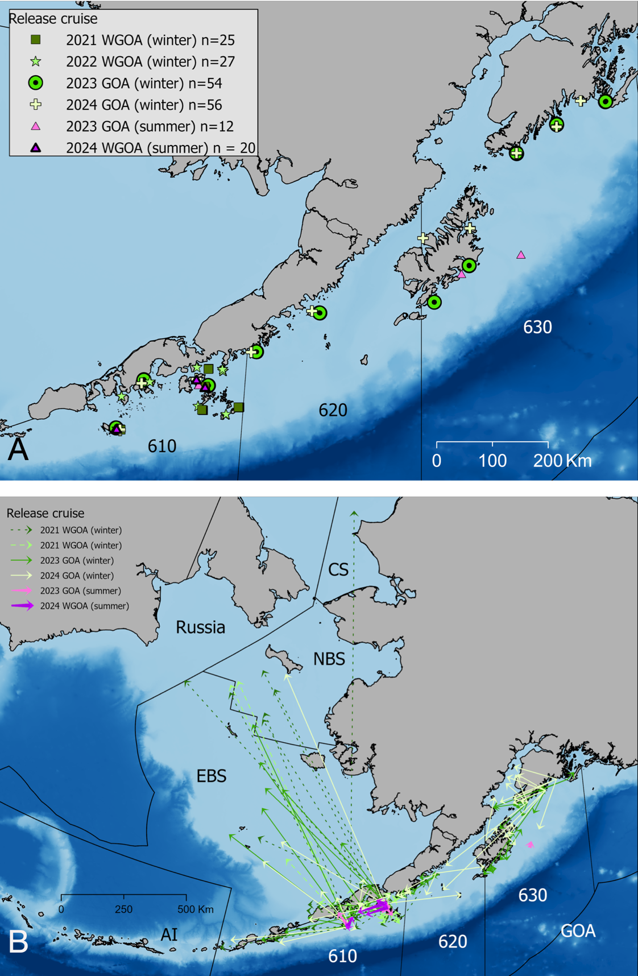

##### Figure 2.2 Pacific cod satellite tag A) release locations in Gulf of Alaska (GOA) management areas 610, 620, and 630 from 2021 – 2024 and B) pop-up locations from GOA satellite tag releases by region (AI = Aleutian Islands, EBS = Eastern Bering Sea, NBS = Northern Bering Sea, CS = Chukchi Sea).

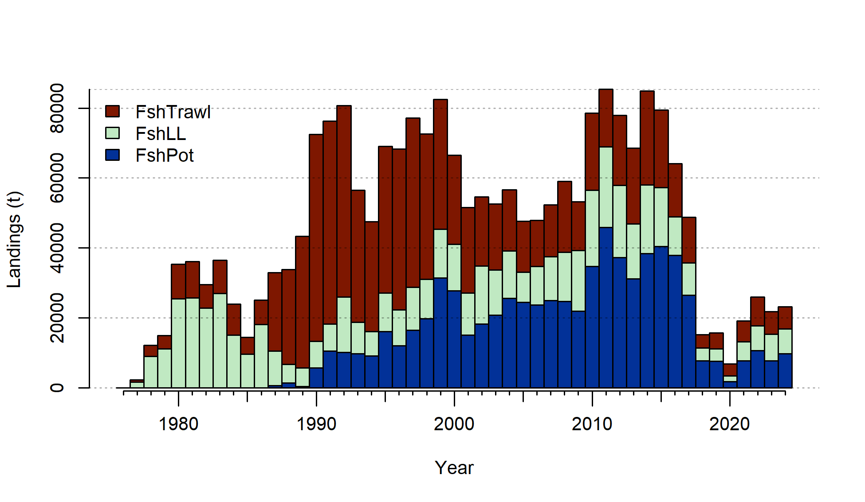

##### Figure 2.3. Commercial catch (mt) of Pacific cod in the GOA in trawl (FshTrawl), longline (FshLL), and pot (FshPot) gear from 1977-2024. Note that 2024 catch was through October 17.



##### Figure 2.4. Commercial catch of Pacific cod in the GOA by 20km2 grid for 2015-2024.

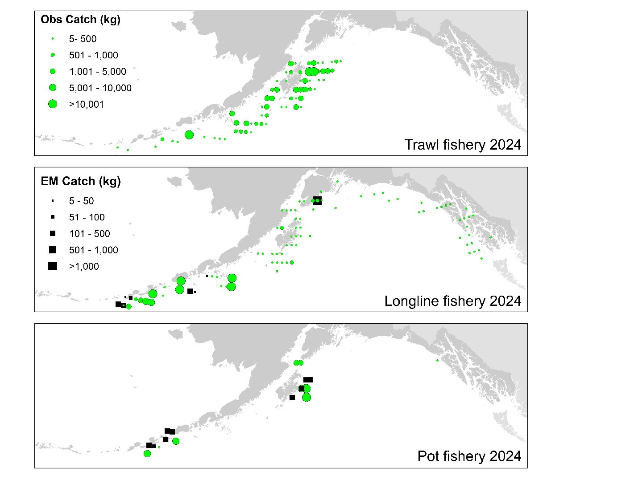

##### Figure 2.5. Observed (Obs) and electronic monitored (EM) commercial catch of Pacific cod in the GOA by 20 km2 grid for 2023. These data include bycatch Pacific cod, but do not include trawl EM data as locations are not yet available.



##### Figure 2.6. Vessel participation in the directed cod fishery by year, GOA sub-region, and gear type.



##### Figure 2.7. Cumulative catch week of the year for 2020-2024 by GOA sub-area and fleet (2024 catch through week 43).



##### Figure 2.8. Auxiliary indices for GOA Pacific cod adult and recruitment abundance. ADFG bottom trawl survey delta-glm density (top left panel) and proportion of Pacific cod bycatch in the GOA shallow water flatfish fishery (bottom left panel) representing indices for adult abundance, and age-0 beach seine survey numbers per haul (top right panel) and proportion of pelagic trawls in the Central GOA A Season (January-April) walleye pollock fishery with Pacific cod present (bottom right panel) representing indices for recruitment.



##### Figure 2.9. Data fit in the author’s recommended model. Circles are proportional to total catch for catches, precision for indices and input sample size for compositions and length-at-age observations. Data source include fishery data from trawl (FshTrawl), longline (FshLL), and pot (FshPot) fisheries. Survey data include the AFSC longline (LLSrv) and bottom trawl (Srv) surveys. Note that since the circles are scaled relative to maximum within each type, the plots of scaling across dataset types should not be compared.



##### Figure 2.10. Distribution of AFSC bottom trawl survey catch (kg) of Pacific cod for 2019-2023.



##### Figure 2.11. Distribution of AFSC longline survey catch (numbers) of Pacific cod in 2022 and 2023.

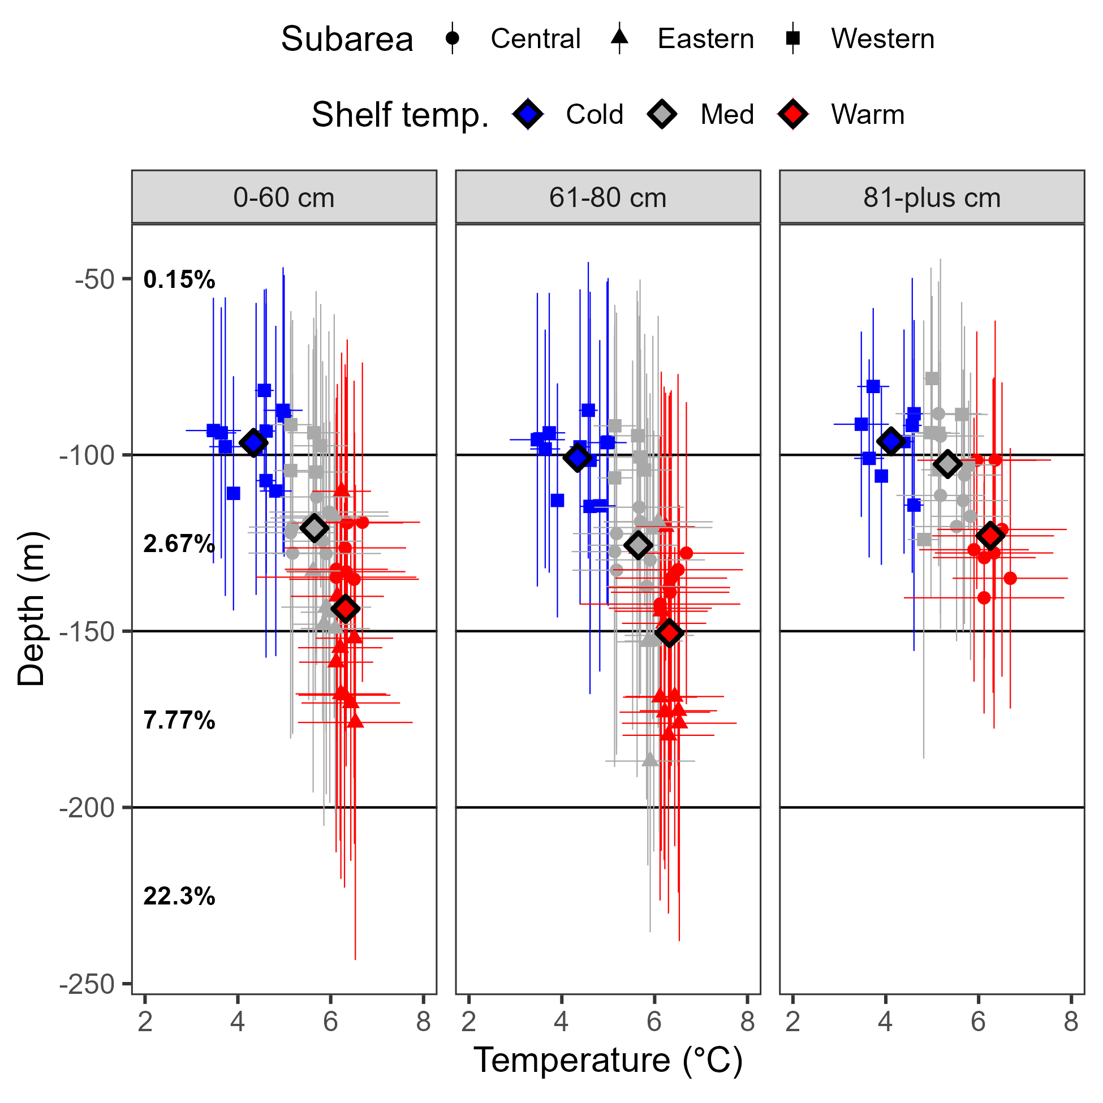

##### Figure 2.12. Area-weighted observed bottom temperature compared to CPUE-weighted depth of Pacific cod from the AFSC bottom trawl survey for different size classes. ‘Cold’, ‘Med’, and ‘Warm’ temperatures are defined as 33% percentiles of observed area-weighted bottom depths. Horizontal black lines indicate the depth strata for the AFSC longline survey that overlap with GOA Pacific cod depth distribution, and bold black text is the proportion of hatchis deployed by the AFSC longline survey in these depth strata.



##### Figure 2.13. Climate Forcast System Reanalysis (CFSR) central GOA bottom temperatures anomailies at the AFSC bottom trawl survey mean depths for 0-20 cm Pacific cod in June used as a covariate to the AFSC longline survey catchability.

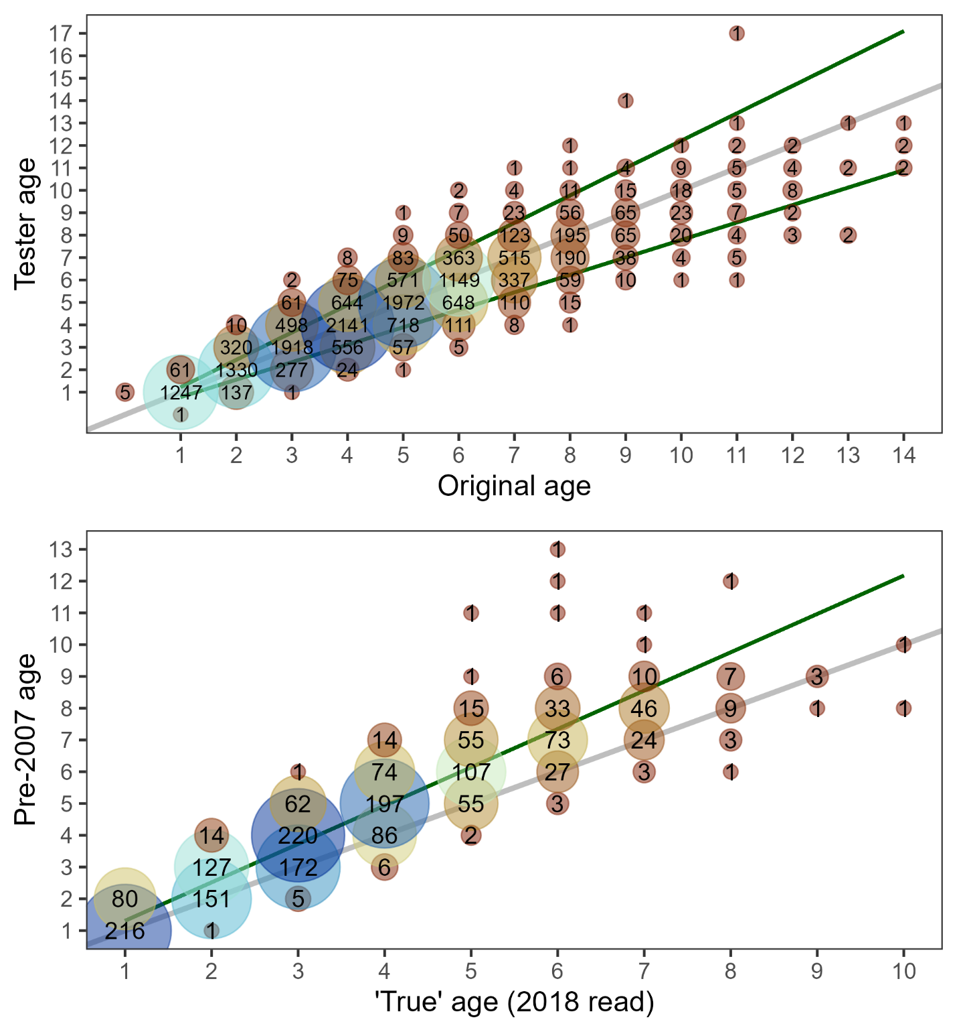

##### Figure 2.14. Reader-tester paired ageing data used to estimate ageing error (top panel) and otoliths read originally in 2007 that were reread in 2018 used to estimate ageing bias (bottom panel). Estimates of uncertainty in age reading (95% confidence intervals) and bias in ageing as estimated by the AgeingError R package are shown with green lines in each panel, one-to-one reference is shown by the grey line in each panel.

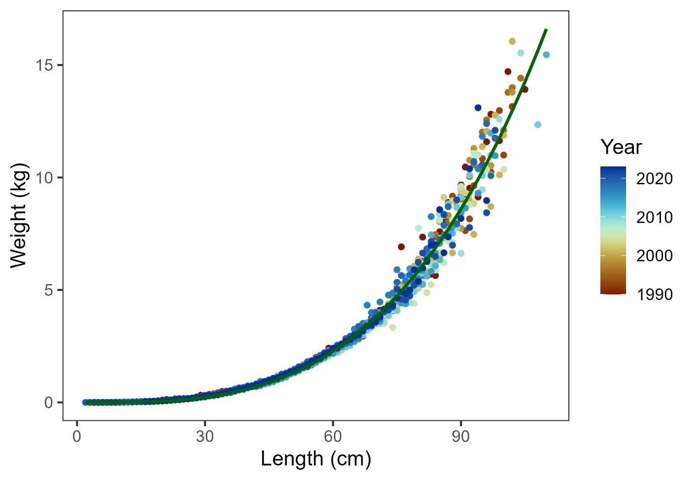

##### Figure 2.15. AFSC bottom trawl survey and age-0 beach seine survey observed weight-at-length (points) and fit used in the recommended assessment shown with the solid green line.

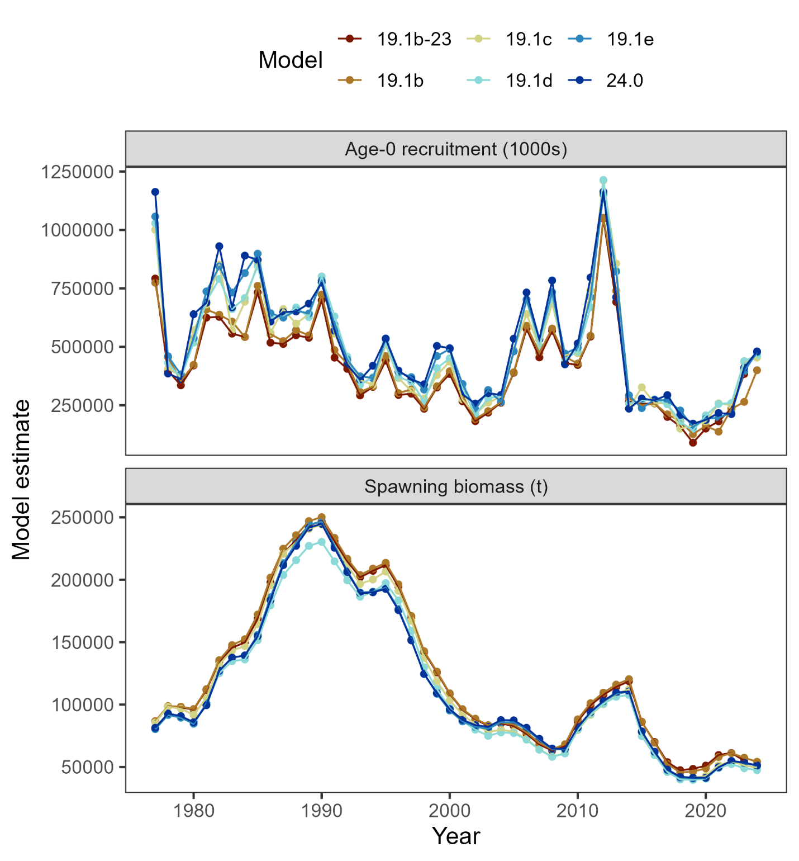

##### Figure 2.16. Comparison among alternative model estimates of age-0 recruitment (top panel) and spawning biomass (bottom panel).

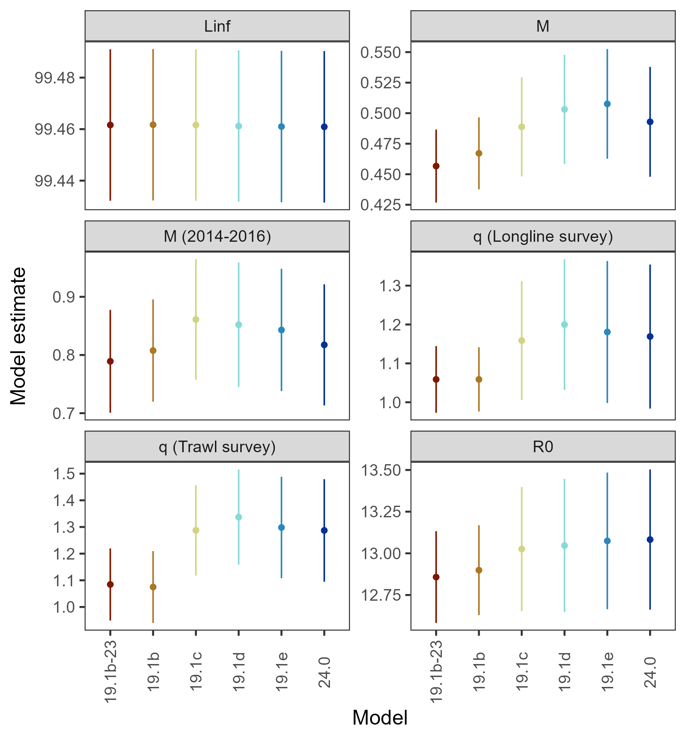

##### Figure 2.17. Comparison among alternative models of key parameter estimates with 95% confidence intervals.

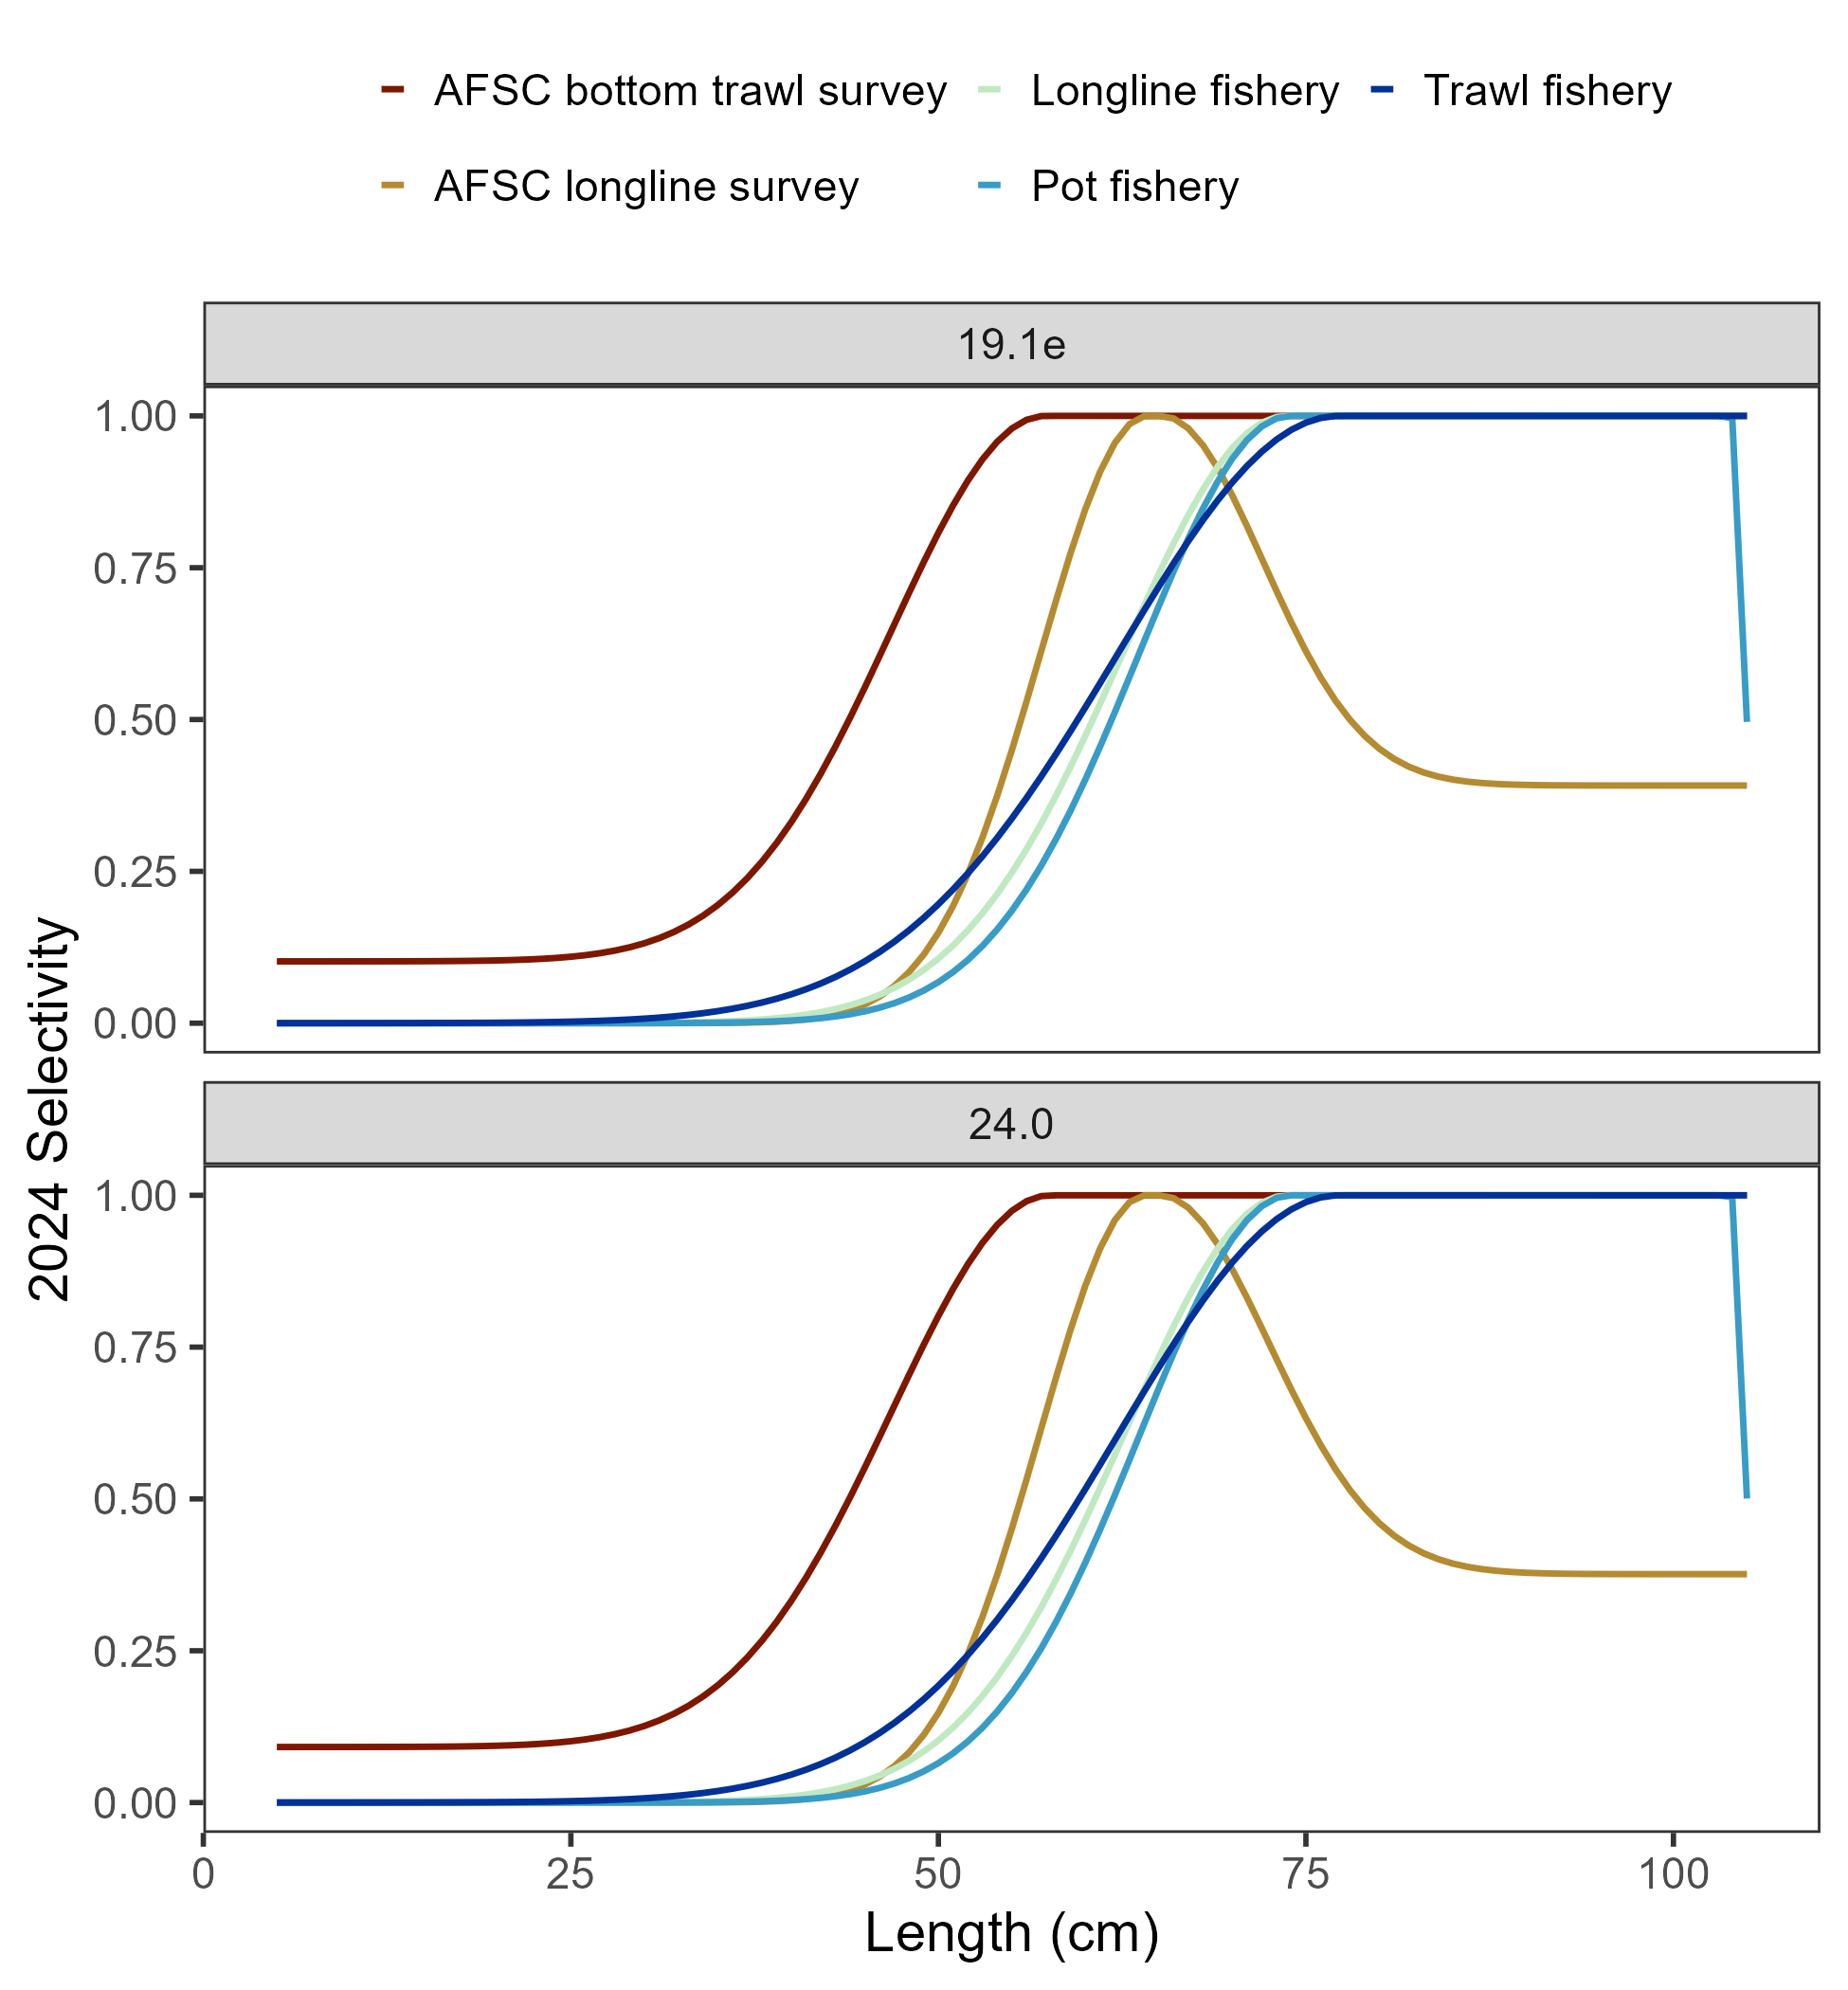

##### Figure 2.18. Comparison among alternative models estimates of current year selectivity with 1 cm length bins (19.1e) and 5 cm length bins (24.0).



##### Figure 2.19. Retrospective analysis of spawning biomass upon removing data from the author’s recommended model (top panel) and in comparison to previously accepted models (bottom panel). The shaded region is the 95% confidence intervals from the author’s recommended model.

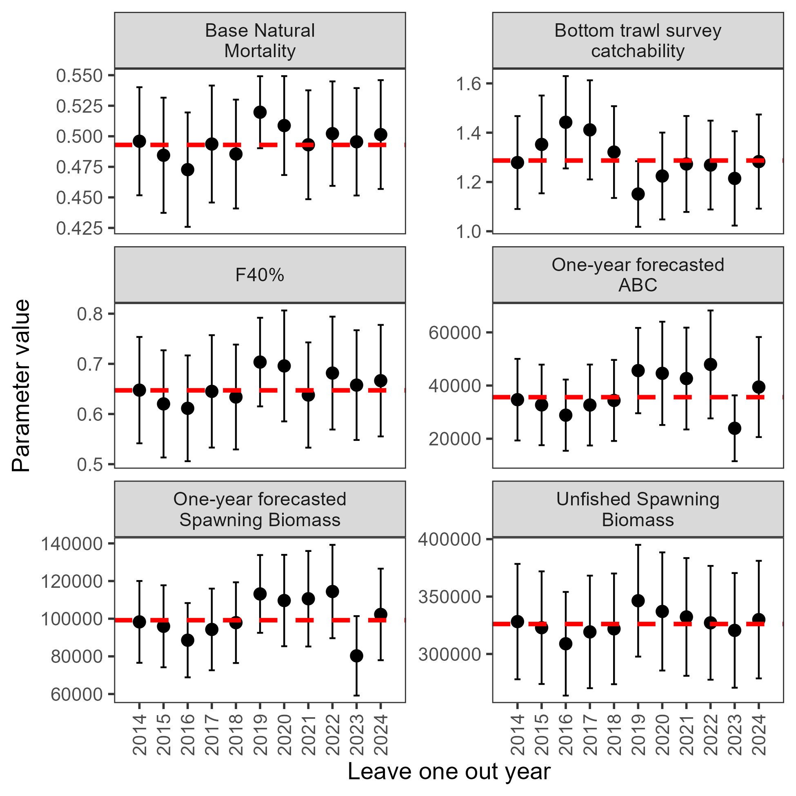

##### Figure 2.20. Leave-one-out analysis showing parameters and derived quantities as one year of data were removed from the model fit of the author’s recommended model. The horizontal dashed line denotes the author’s recommended model’s estimate.

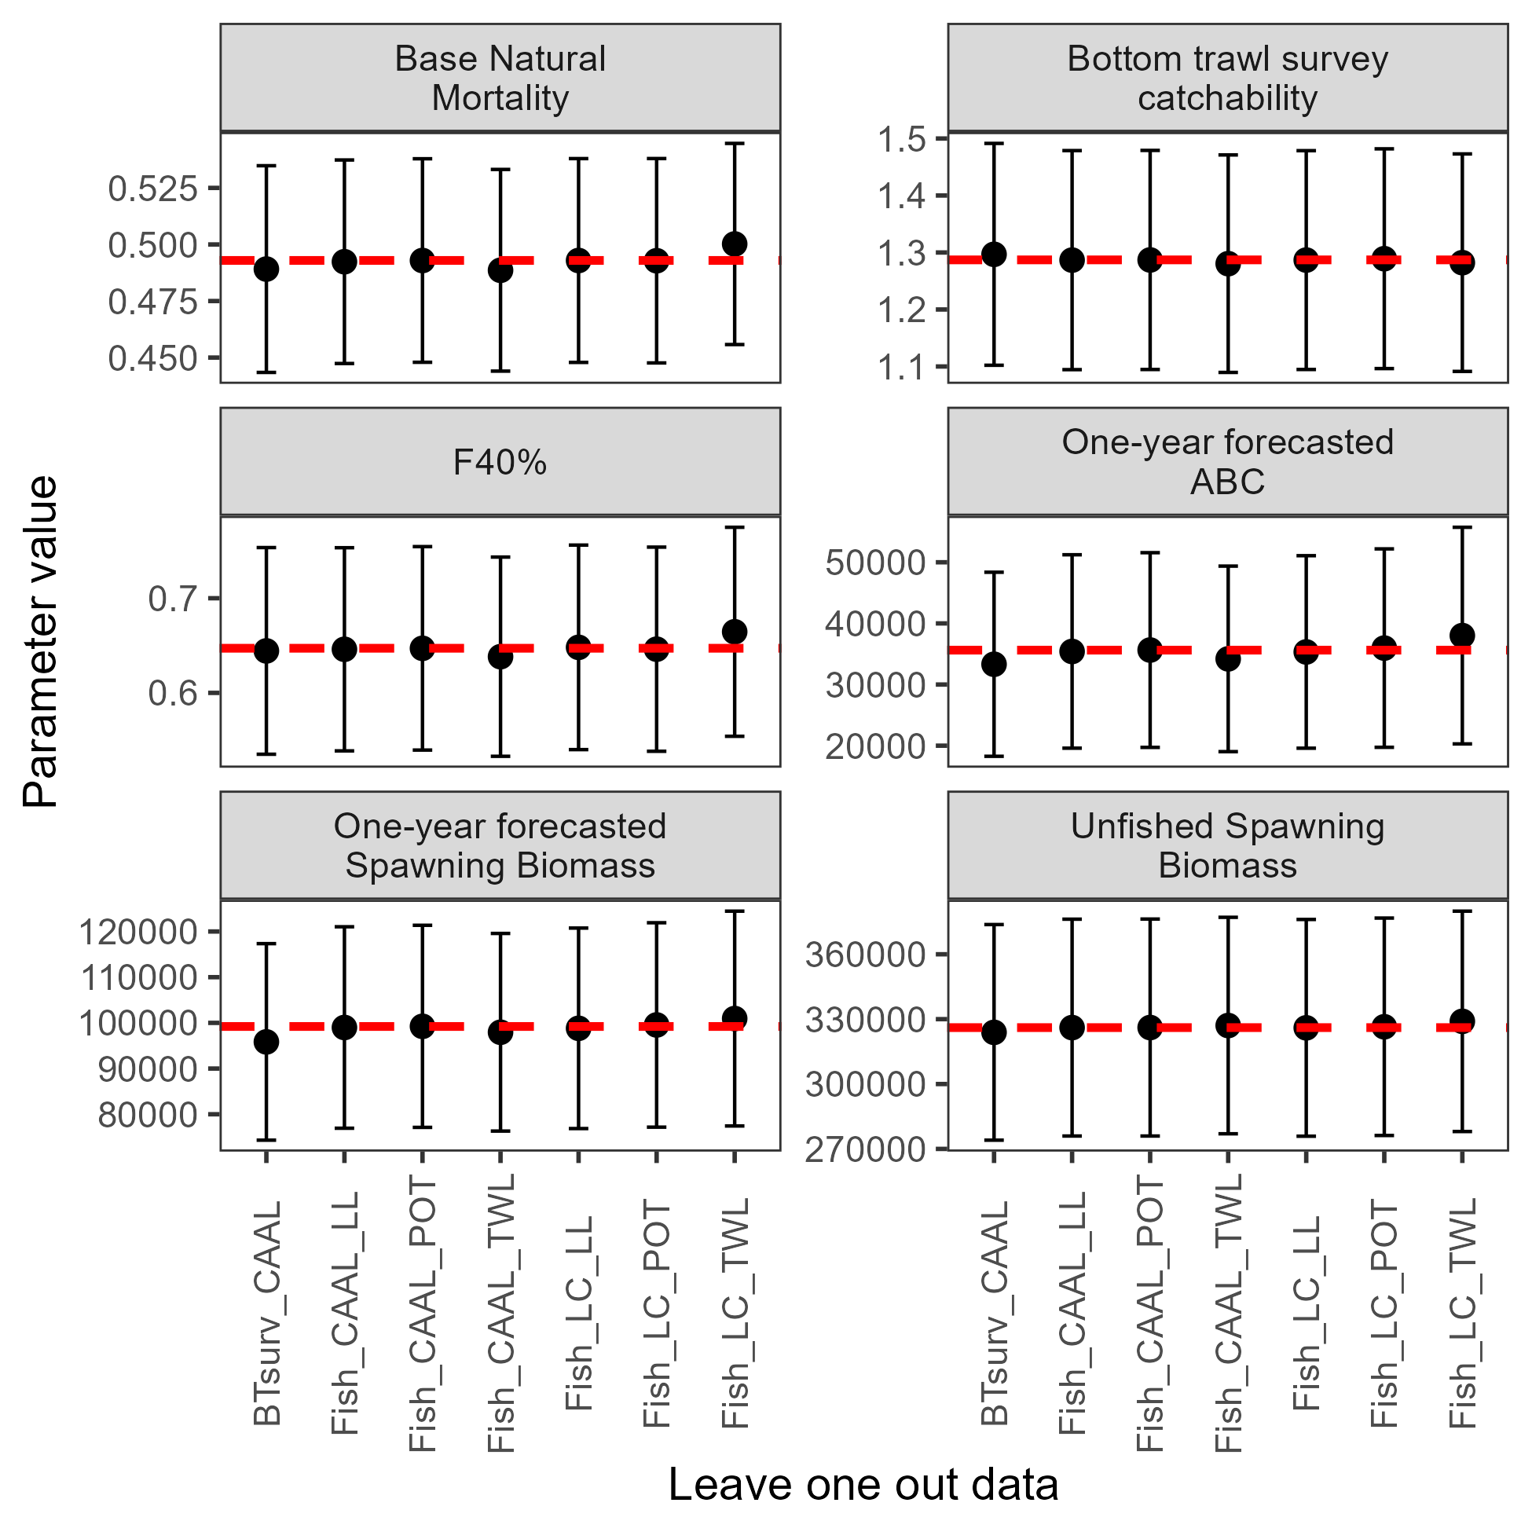

##### Figure 2.21. Add-one-in analysis showing parameters and derived quantities as each data source were added to the author’s recommended model. CAAL denotes conditional age-at-length data, LC denotes length comp data, and Indx denotes index data from the bottom trawl survey (BTsurv), longline survey (LLsurv) and fisheries (denoted with gear type). The horizontal dashed line denotes the author’s recommended model’s estimate.

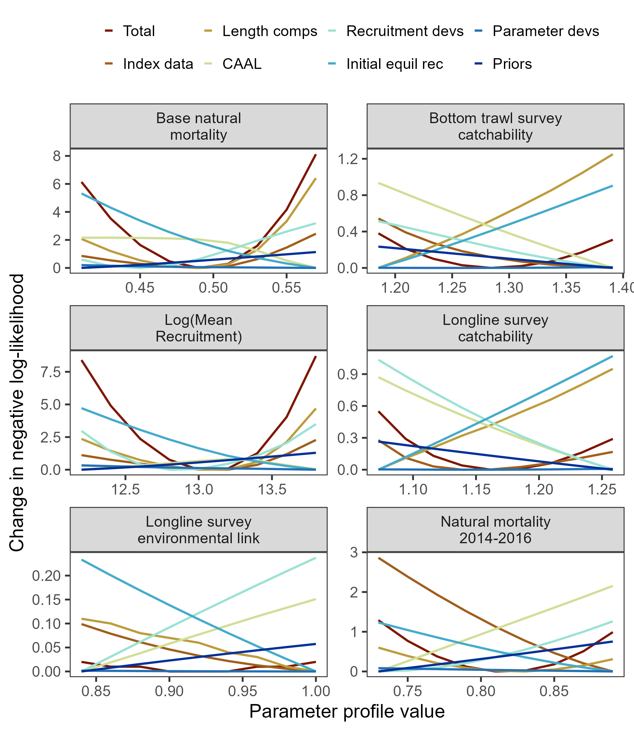

##### Figure 2.22. Negative log-likelihood profiles for key parameters estimates in the author’s recommended model.



##### Figure 2.23. Population indices fit by the assessment model, including AFSC longline survey relative population numbers (RPN – top panel) and AFSC bottom trawl survey abundance (numbers – bottom panel). Model fit is shown as a solid line and observed data is shown as points (with error bars indicating the 95% confidence intervals).

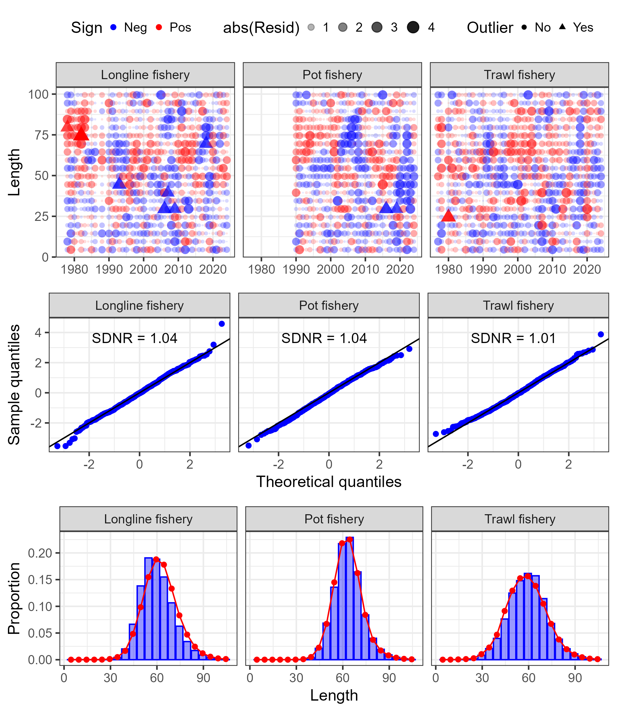

##### Figure 2.24. One-step ahead residuals (top panels), theoretical versus sample quantiles (middle panels), and aggregated model fit (bottom panels) for the fishery length composition data (fleets shown across the columns) fit in the author’s recommended model.

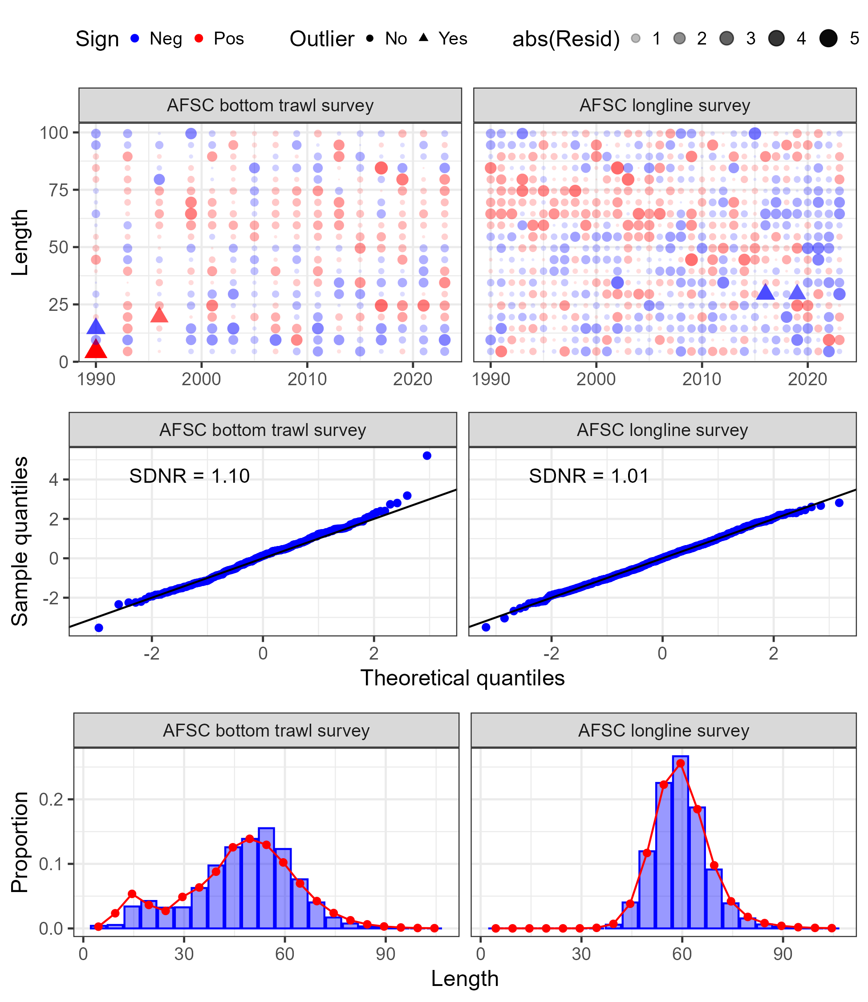

##### Figure 2.25. One-step ahead residuals (top panels), theoretical versus sample quantiles (middle panels), and aggregated model fit (bottom panels) for the survey length composition data (surveys shown across the columns) fit in the author’s recommended model.

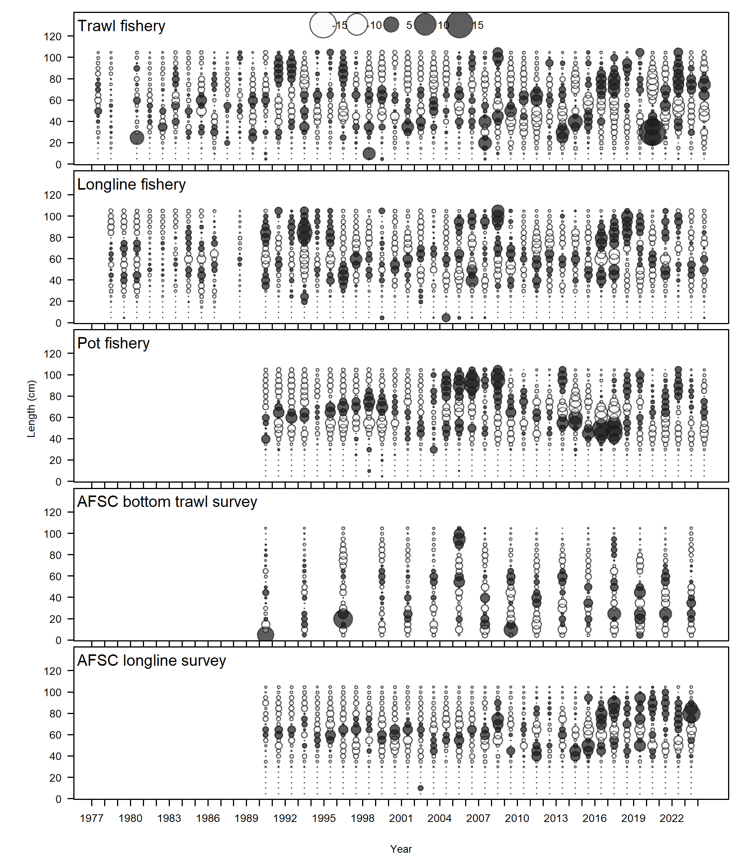

##### Figure 2.26. Pearson residuals for the fishery and survey length composition data fit in the author’s recommended model.

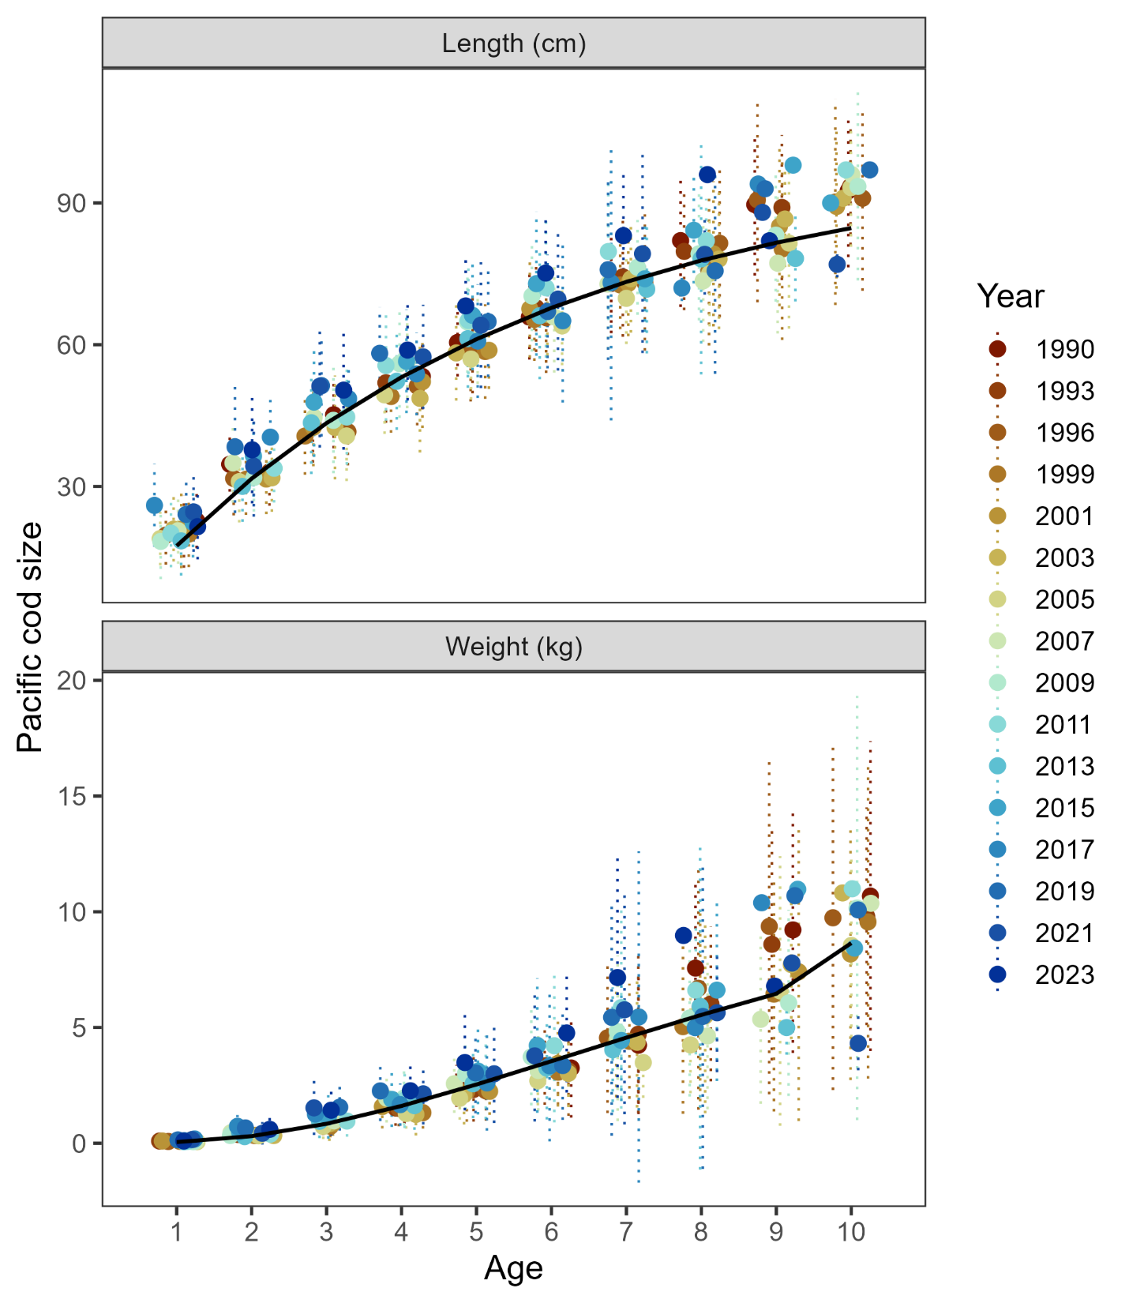

##### Figure 2.27. Author recommended model fit (solid line) to AFSC bottom trawl survey observed mean length-at-age (top panel) and weight-at-age (bottom panel) across the years of the survey (ranges shown are the 95% confidence interval in the yearly mean length or weight).

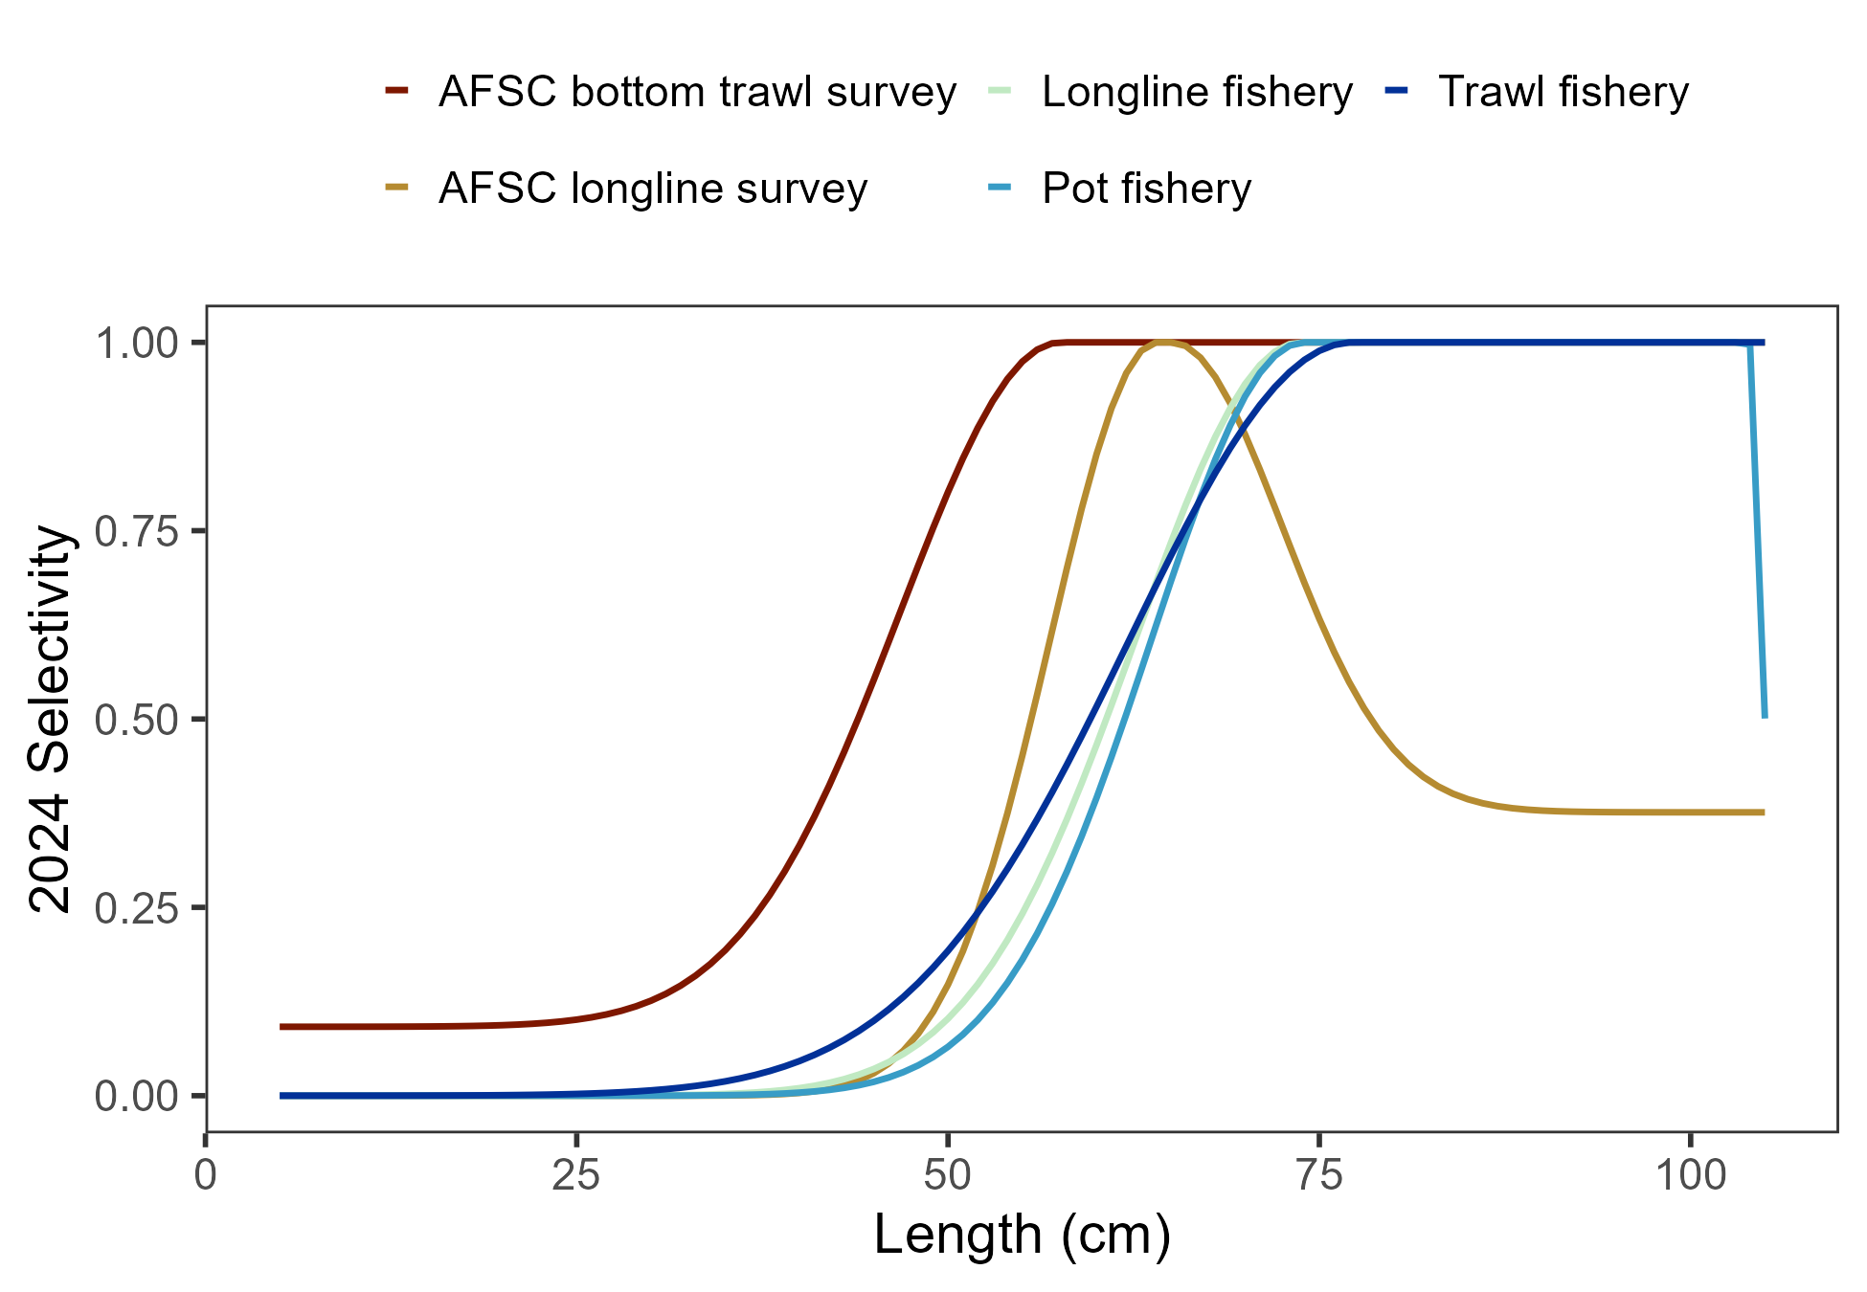

##### Figure 2.28. Current year estimated selectivity from the author recommended model.

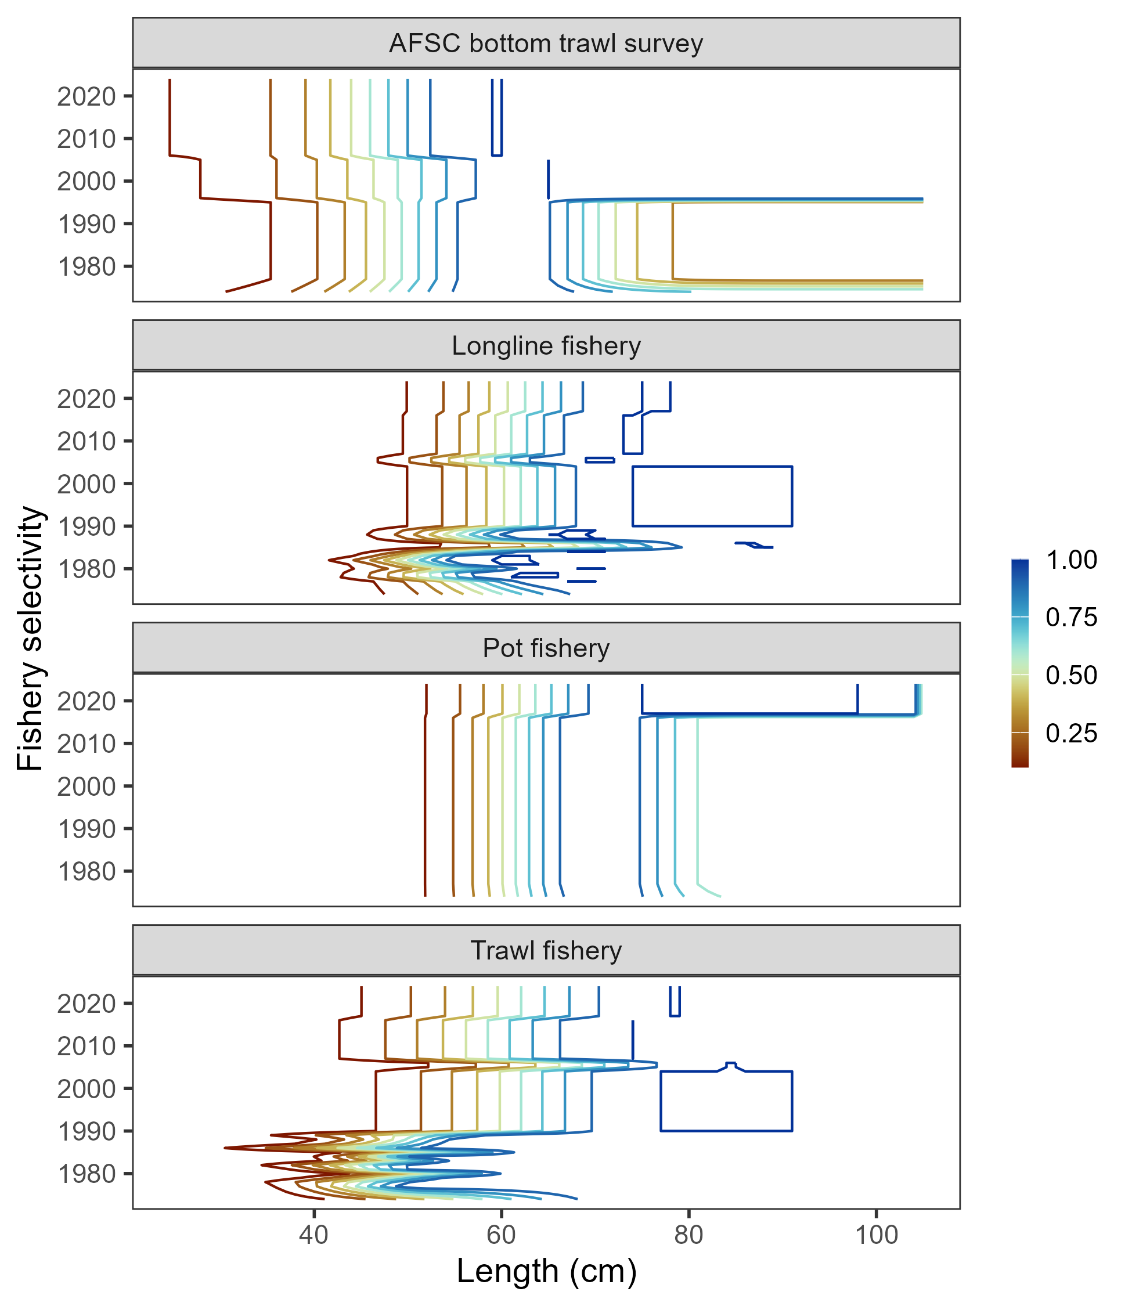

##### Figure 2.29. Estimated selectivity from the author recommended model across time.

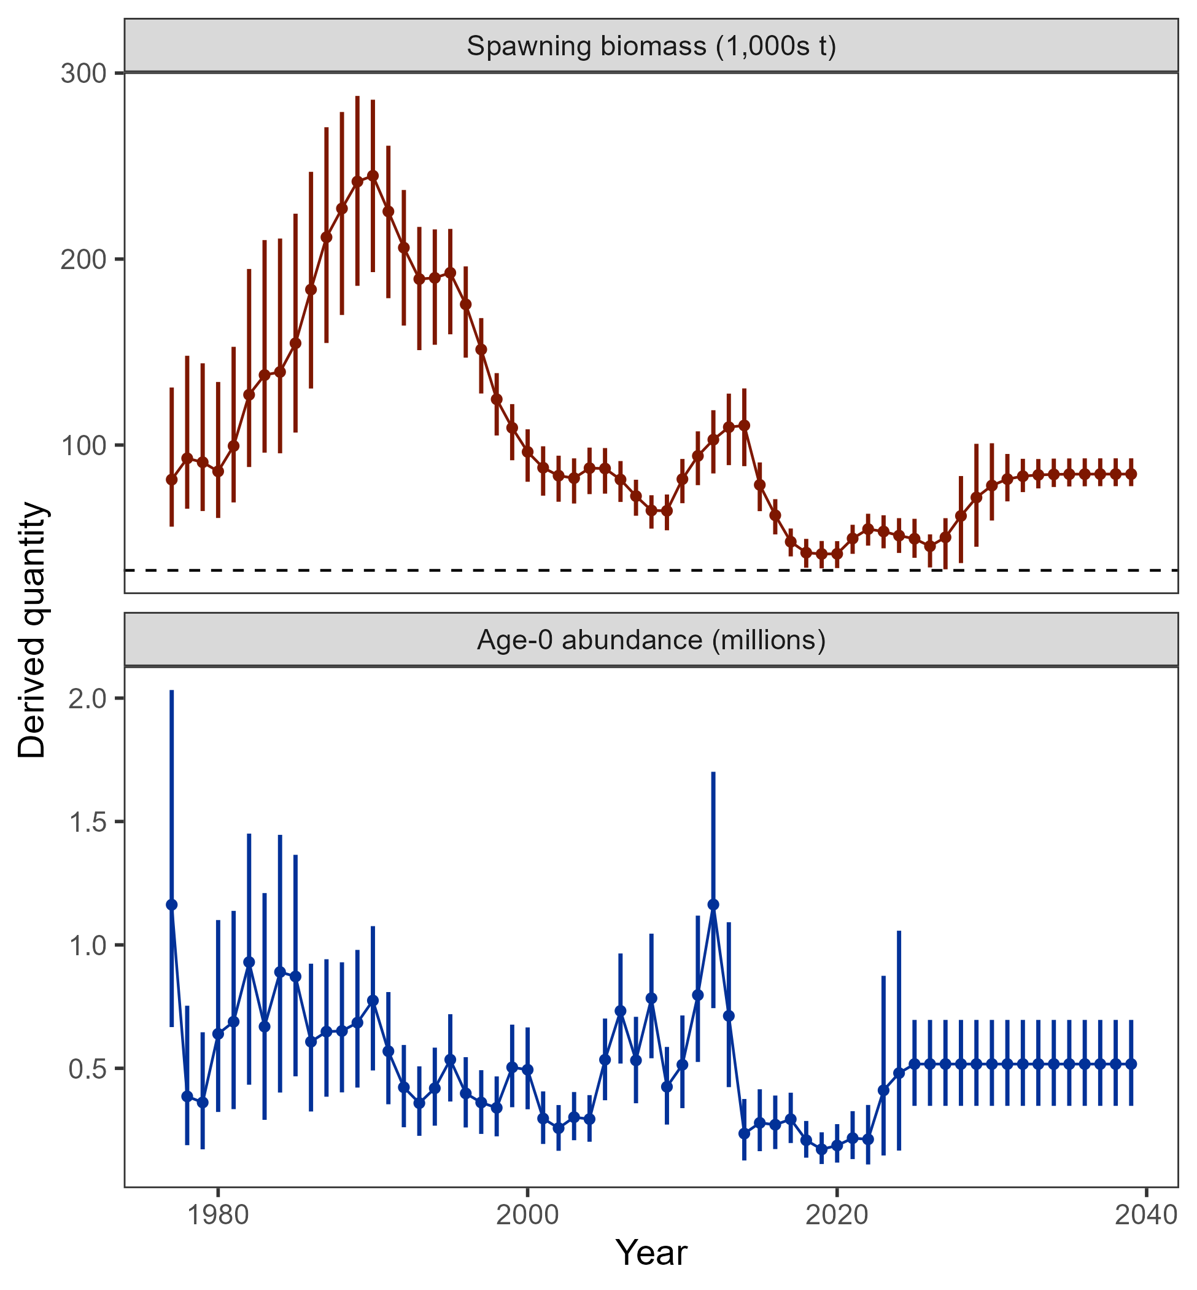

##### Figure 2.30. Estimated spawning biomass (top, dotted line is the projected SSB*20%*) and age-0 abundance (bottom) from the author’s recommended model with 95% credible intervals from the MCMC.

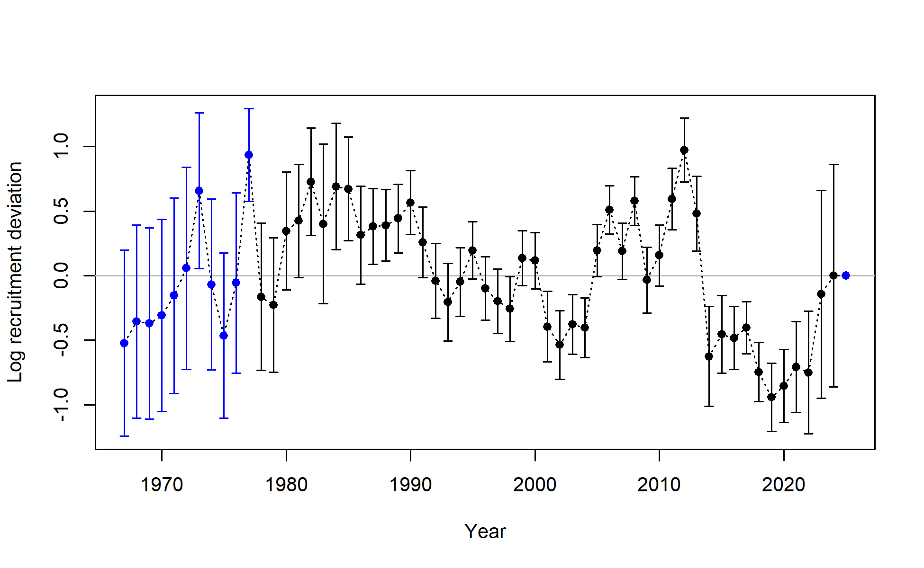

##### Figure 2.31. Log recruitment deviations with 95% asymtotic error intervals from the author’s recommended model.



##### Figure 2.32. Predictions of middle of the year number at age with mean age (red line) from the author’s recommended model.



##### Figure 2.33. Sum of apical fishing mortality (top) and continuos fishing mortality by fisheries (bottom) from the author’s recommended model.

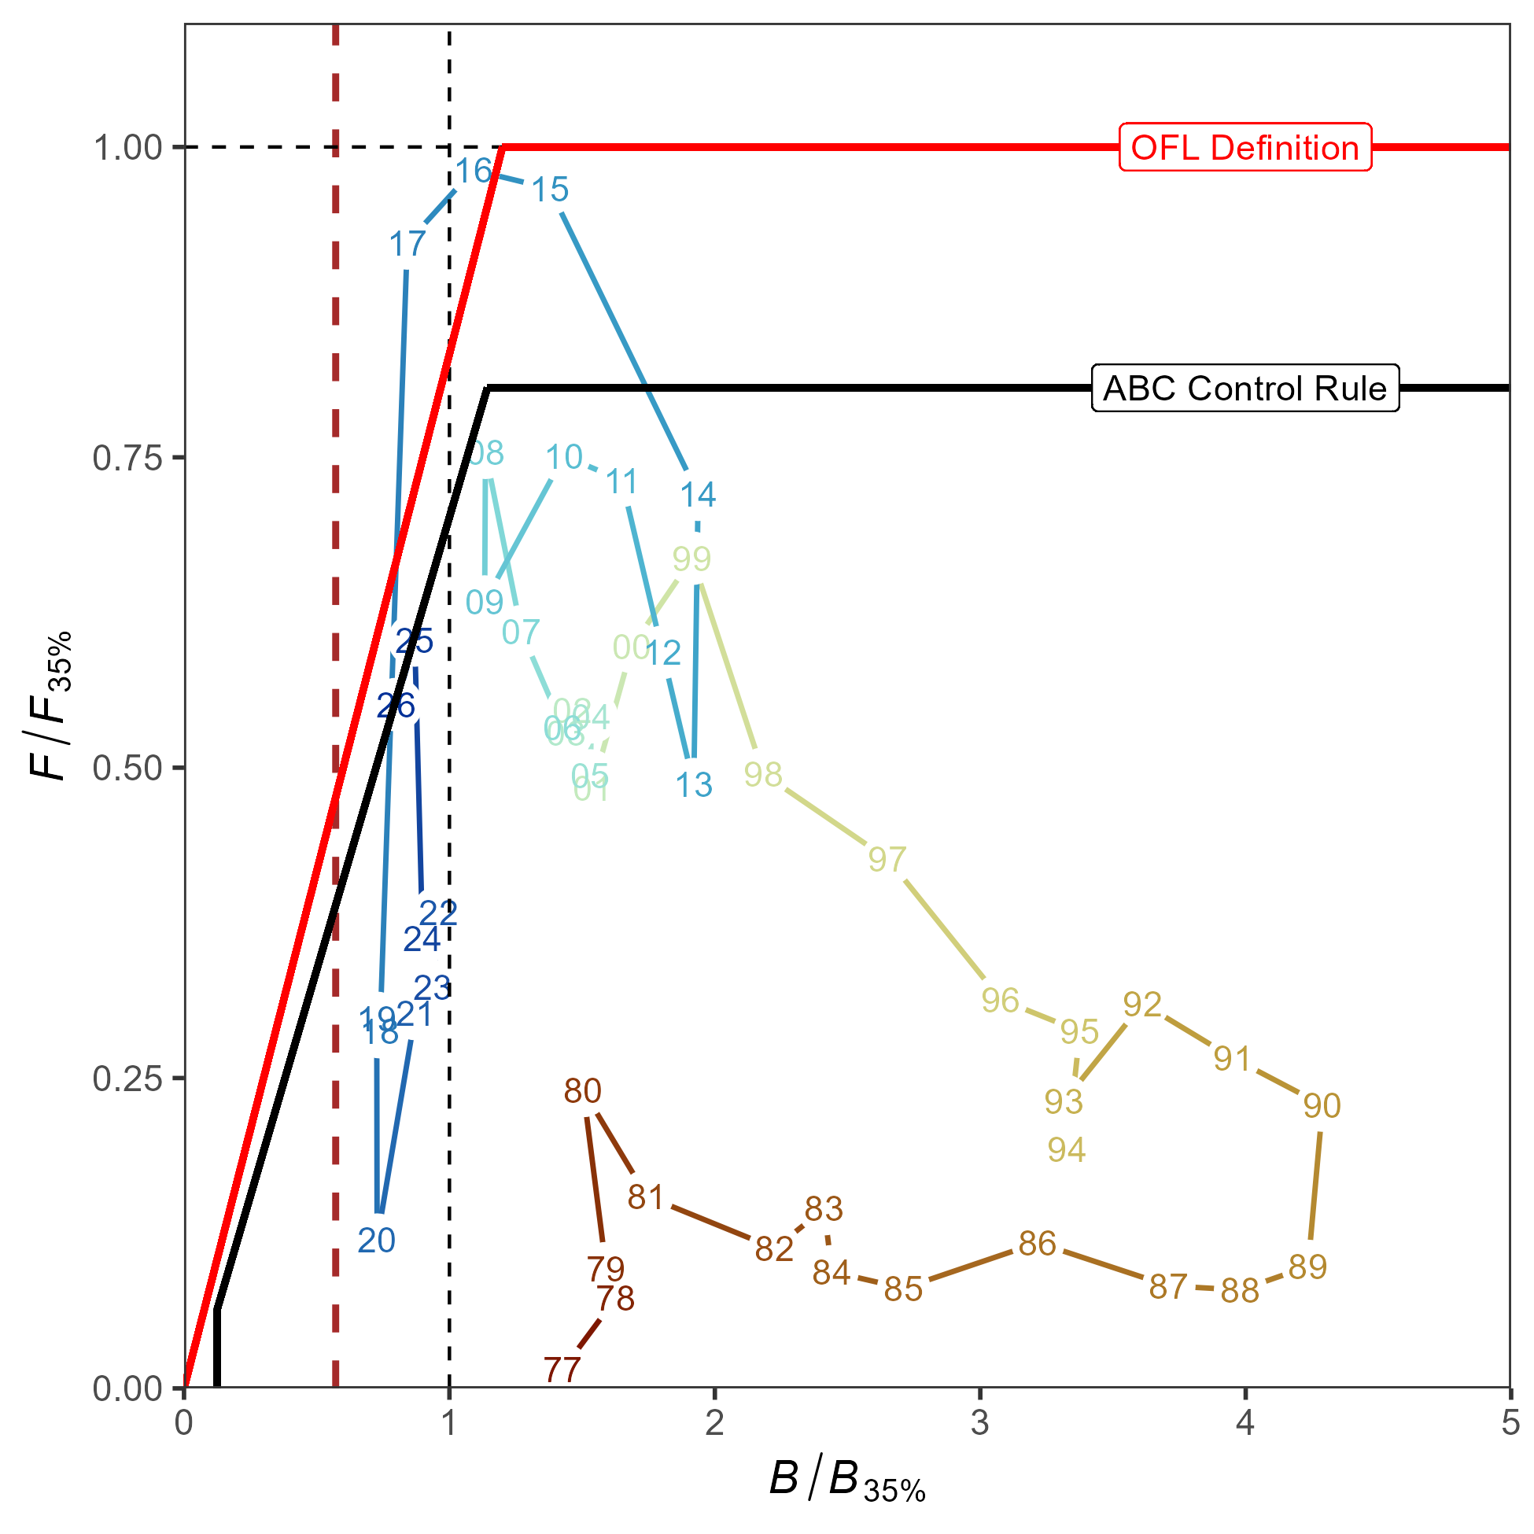

##### Figure 2.34. Ratio of historical *F*/*F35%* versus female spawning biomass relative to *B35%* for GOA pacific cod, 1977-2026 from the author’s recommended model. The Fs presented are the sum of the full Fs across fleets. Dashed red line is at B*20%*, Steller sea lion closure rule for GOA Pacific cod.

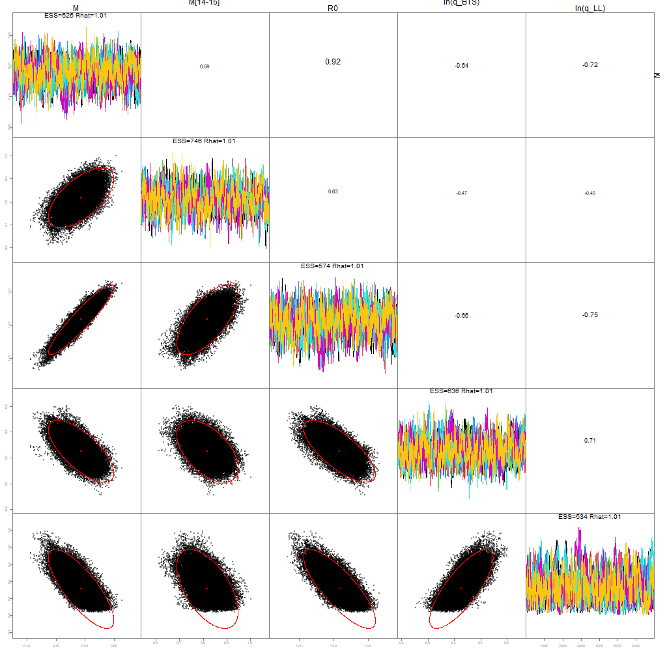

##### Figure 2.35. MCMC pairs plot of key model parameters, with diagnostics shown in the diagonal and parameter correlations shown in the top right.



##### Figure 2.36. Histograms of MCMC draws for key parameters from the author’s recommended model compared to MLE estimate (vertical line).

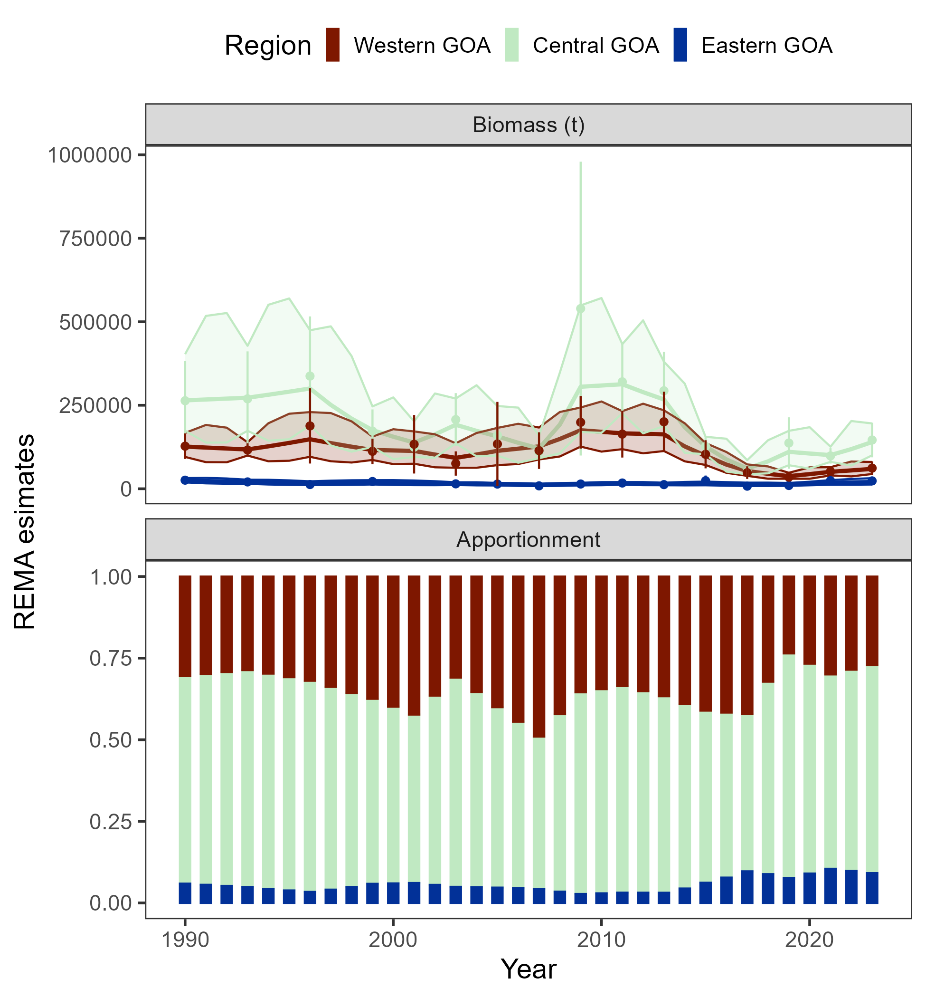

##### Figure 2.37. REMA results as fit to the AFSC bottom trawl survey by area (top panel) used for apportionment (bottom panel).